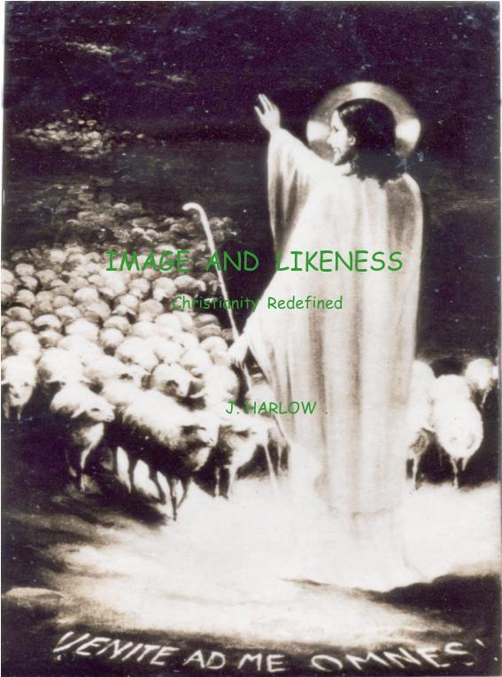
Image and Likeness J. Harlow, 2017 ©

Christianity in 100 pages, complete in one book.

A new way to convey the whole of the Christian religion to anyone of goodwill.

Image and Likeness

Christianity REdefined

J. HARLOW B.A., A.MUS.A., U.WA

Copyright © J. Harlow 2017

Printed in China. All rights reserved. No part of this publication may be reproduced, stored in a retrieval system or transmitted in any form or by any means, electronic, mechanical, photocopying, recording or otherwise, without the prior written consent of the copyright holder.
CONTENTS
Page
KEY CHART vii
THEME ix-xii
PART ONE .. UNION with God 1-20
Creation Chart 5
New Species - Baptism 6-11
How to Baptise 7
Baptism's effects 8-11, 16, 20, 26, 33
Penance, Sacrament 12-16
Christ Risen 17-19, 25, 45,79-82
Bible, History of Redemption 21-25
PART TWO ... LIKENESS to Christ 27-66
Supernature, the Sacraments 30-37
Baptism 3-11, 31-39, 54-55
Penance 12-16
Confirmation 40-41
Eucharist 42-49
Marriage 50-51
Holy Order 51, 94-97
Last Anointing 52-53
Other Ways, and In General 54-55

WHAT IS THE CHURCH? 57-66, xvi, xvii
Framework and Birth 64-65
Peter Pre-eminent 62-65, 95
Last Chance 65
Early Years, A.D. 33-55 84
A.D. 55-1970 85
By Whom Rejected 65, 81-82, 85
PART THREE … SACRIFICE, Christ's 67-97
Of Good Friday 70-71, 73, 75, 79
Defined 72-74
Last 0f Old Testament – First of New 75-76
Foreshadowed 75
Forewarned 80
Effect 77
History 77, 81-82
How Understood : A.D. 33-55, A.D. 55-1970 84, 85
Christ's Sacrifice Today 86-89
Technicalities of Eucharist 90-93
Holy Order - Source of Sanctifying Grace 94-97
WHAT IS MAN 97
MARY'S PART 98-99
I AM THE WAY ix-xii, 1-100, xiii-xiv
Notes xv-xvii
Chronology New Testament xviii-xx
Acknowledgments & Bibliography xix
Index xxii

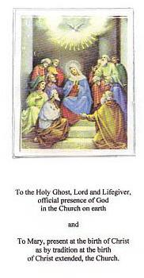

IMAGE AND LIKENESS

CHRISTIANITY REDEFINED

(Insert picture)

“…a man was not made to pace out his life behind the prison walls of nature
but to walk into the arms of God on a road that nature could never build.”
Farrell, W. & Healy, M.J., My Way of Life – The Summa Simplified for Everyone, N.Y. 1952, p.1

The Prayer that only Christians may say:

Our Father who art in Heaven,
hallowed be thy name.
may thy Kingdom come,
may thy Will be done on earth as it is in Heaven.

Give us this day our daily bread;
Forgive us our trespasses as we forgive them that trespass against us.
And lead us not into temptation but deliver us from evil.

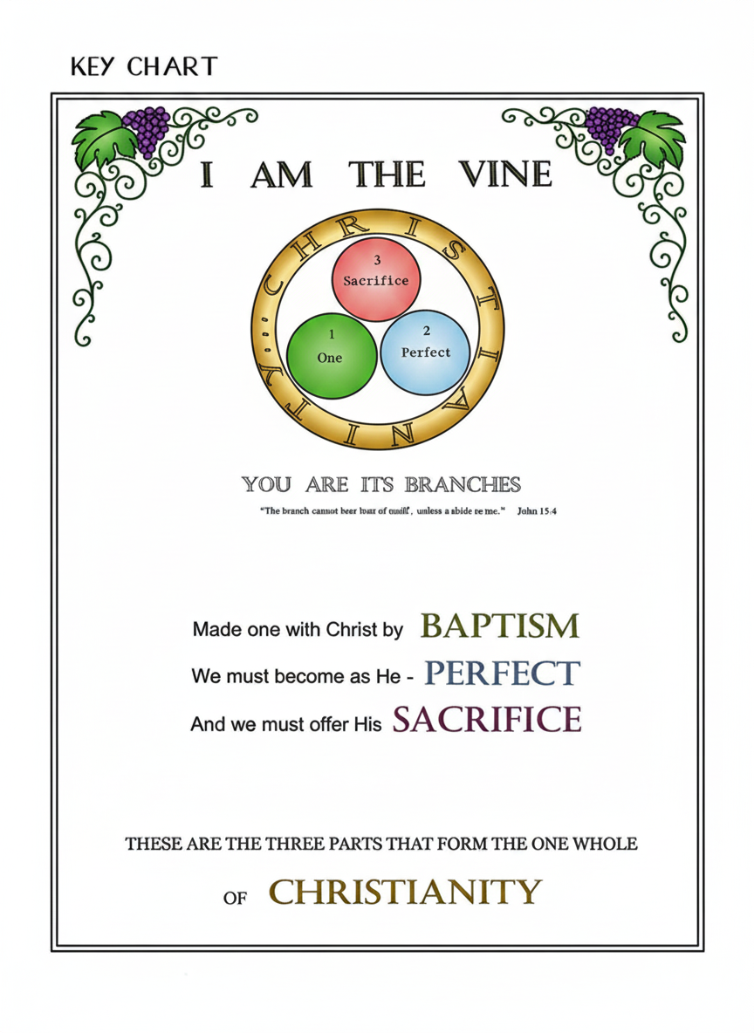

Image and Likeness
CHRISTIANITY PRESENTED AND PROVED

we are made in the image of God;
we need to achieve likeness to God;
that is the intention of Creation.

IMAGE AND LIKENESS Genesis 1:26 “Let us make man to our image and likeness.”

Christianity is precise, a science. It is not an emotion-based amalgam for wishful thinkers or preachers of what they practise, all claiming true and complete Christianity, but that all religions are the same - all on the road to Heaven, just by different routes.
The fact is, only one route was laid down. Its content and distinguishing features are set out in sequence in this volume, directed mainly for the instruction of High School students, but setting out also certain facts underlying our existence which today cannot be assumed to be part of an Instructor’s knowledge base.

The first of these concerns the fact of our own existence and that of the universe in which we subsist, and leads to acceptance of perhaps the most difficult concept in the range of human understanding: namely that for us and this earth to exist there must also exist Someone who always existed, who had no beginning, and who has brought us and our world into existence. Any other conclusion is puerile, since neither matter nor spirit is self-generating.

There is one such Being, who styled himself in recorded history ‘I AM WHO AM’, and the state of existence into which he has brought us is like his own, never ending. The moment we are born, in fact conceived as human beings, we step into eternity. Our Spirit having no physical parts continues to exist when by the law of nature our Body dies its temporary death. Both Spirit and Body by the will of the Creator will eventually be rejoined as a living entity, in a life without end. We know this because Man is “made in the image” of One who is pure Intellect and Will, having no physical parts, who has made in us a species both spiritual and physical, able to interact with Him in speech and understanding and who has made known to us this fact concerning our ultimate state.

It follows also from the unlikelihood of so stupendous a universe being created for the use and benefit of mere animals that after death can continue only in the species, not singly.

Much of our knowledge about ourselves has been imparted to individuals and recorded by them, largely in the Old and the New Testaments. These record Creation, often in a manner suitable to minds now grown dulled, unlike the pristine quality of mind of the first man created. They also record the triune nature of man's Creator, obscurely in the Old Testament but unequivocally in the New.
Man then is made "in the image of God", with an intellect able to gather and assess truth and with a will able to accept or reject truth, his spiritual qualities ennobling his physical form.

But Man is also made "in the LIKENESS of God".
"Image" denotes a fixed quality, a specified type, unalterable; but 'Likeness' has the potential inherently to grow, to expand. Only a being made in the image of God could also achieve likeness to God. The ways set down for this growth to occur, intended from creation, are examined and explained in this book.

The model of likeness in which Man is ideally to grow is in Likeness to Christ, who was both Man and God. "In every genus…there is something that is most perfect for that genus… Thus white is said to be the measure among all colours, and the virtuous man among all men." For us Christ is the "virtuous man", who being also God is the measure for all those who begin to share by Baptism the supernatural life.

Likeness to Christ cannot come from Man's natural qualities. Whatever excellence of mind, body and achievements Man may exhibit arises from his natural will and conscience, but these alone will not lead to the state of union with God envisioned in the first act of Creation and enjoyed by the first human couple when they walked in the Garden of Eden.

It comes from a quality not found in Man's nature and must be added to it, a 'super-life, non-physical, purely spiritual; lost by the first human pair in proud rejection of their need for it. The 'image' remained, but distorted. Their descendants, the human race, were born without the spiritual link to the unseen God, their creator, and would be barred from Heaven by the lack of it.

But man, each ‘man-image-of-God’, is made for happiness, and for him happiness is achieved only in Heaven, in the Vision of God: seeing God ‘face to face’ at his life’s end, which is also his eternity’s beginning. Restitution leading to re-instatement of the link to God not being possible for man of his nature to make, God the Son himself joined the human race, and offered his life in infinite satisfaction of the debt. Man could then achieve the goal of perfect happiness set for him, given each man’s willing assent.

Because free access for all men to this spiritual quality was involved, Christ made an institution, His Church, in which the supernatural gift would always be available: the gift by which a man could attain likeness to Him and thereby merit Heaven. This Church would contain all of Christ’s teaching, guarded perpetually from error by the presence in it of the Third Person of God, the Holy Ghost. It would have a governing structure for good order.

Such is the Christian Church when viewed undistorted by heresies constantly arising throughout the centuries. It makes possible for every human person to be absorbed, as by osmosis the less by the greater, into Christ by Baptism; to become increasingly perfect like Him by the ways He laid down; to even participate in His action of Sacrifice that opened Heaven to man, made possible by the manner of death He chose.

Christianity is essentially a supernatural religion, raising man above his natural state to one so immeasurably higher that it is almost impossible to state it accurately and be believed. So long have we lived in a miasma of misrepresentation concerning it that the false has become accepted as the true.

But Christ is still the way, the truth and the life, as set out in the following pages.

The salient feature to grasp from Image and Likeness is firstly that two thousand years ago a way was made for men to join in offering the Sacrifice that redeemed them: that of Calvary; and secondly the existence and necessity of the miracle of sanctifying grace, the x quality without which no human being would be able to see the face of God.

The way to participate in the Sacrifice was made at the Last Supper, more accurately styled 'Last Sacrifice of the OLD Agreement from God towards men and First Sacrifice of the NEW Agreement from God towards men'. All humankind should involve themselves in this Sacrifice as the primary duty and imperative of lives that are to be lived eternally for good or ill. It is also the chief way for each individually to fit himself for eternity. The sanctifying, supernatural Grace all need comes only with Baptism: of water, blood or desire.
🙞

This work contains no unsupported statements. All the doctrine set out is that which has always been taught from Christianity's beginning, codified in defence against pseudo reform by order of the Council of Trent 1545-63; made explicit for teaching purposes in its Catechism, in Latin first to safeguard meaning, but translated immediately into Italian, French, German and Polish, and into English, 124 years later, by command of King James II, 1687.

The 16th century, that called forth that definitive exposition of Christian Faith, The Catechism of the Council of Trent, was a time when, to quote its Introduction, "the Unity of Christ was now almost pull'd and torn to pieces with Schism and Heresies…Impiety, the Child of War, had overspread almost all Europe, and there scarcely remain'd so much as the bare Shadow of Religion. Hardly was there anyone well grounded in the Faith." Those charged with teaching Christianity, the 'Curats', were themselves "almost all void of both Learning and Religion."

The 1500s therefore were a heyday for Heresy, all the more insidious because directed in terms familiar to them, against people who had lived and been governed for over a thousand years under basically Christian precepts, and because supported by "almost infinit Books…carrying in them the Titles and Shews of Piety and Religion". These continue into the 21st century, when their most potent correction, true complete Christianity, is itself in eclipse and Western Society is exposed unguarded to forces inimical to its welfare. This unenviable situation can only be reversed by a return to the norms set out so clearly at Trent.
🙞
The material presented is graded, from the twelve year age group in Part One to the more mature student at University entrance in Parts Two and Three and ancillary sections. It is directed however to all 'men of goodwill'.

Unlike previous Instruction's necessarily defensive mode, Image and Likeness seeks to emphasize firstly Christianity's base-note, Sanctifying Grace, the spiritual additive to human nature without which no man enters Heaven; secondly that Christianity itself exists to extend 'IMAGE' into 'LIKENESS'.

Christianity - PART ONE

“But you are a chosen generation,
a kingly priesthood, a holy nation,
a purchased people, called out of darkness
into his marvellous light: Exod. 19:5-8
Who in time past were not a people:
but are now the people of God.
Who had not obtained mercy:
But now have obtained mercy. 1 Pet. 2:9-10

PART ONE - UNION

“God, Himself one in three distinct persons, was pleased to round off all His exterior works into a unity in man, making man a compendium of all creation, each of the four different divisions being represented in him: the inorganic elements of the earth in his bodily makeup; the vegetative principle of plant life, to feed, grow and reproduce; the sensitive life principle of animals by which they use five senses; the rational life of angels, in their intellect and will. Thus man is a living summary of all creation.
A further component, planned for man alone, was the supernatural life: man empowered to share the real life of the Creator, eternally. Victor Many S.S., Marvels of Grace, authorised translation. Rev. A.D. Talbot S.S., The Bruce Publishing Co., Milwaukee. Geo. Coldwell Ltd., 17 Red Lion Passage, Holborn, WC.1.

* By and after Baptism we live in natural state, linked to the Holy Trinity in supernatural state. *

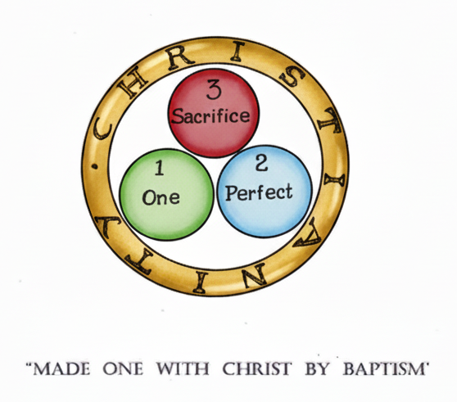

LESSON ONE - A NEW SPECIES

Supposing you go out into your rock bordered rose garden to pick a rose. The "snap" it makes as you break its stem is a sound proper to plant life.

You go back to your verandah, where your little dog is sleeping. You tread on his paw; he yelps and moves away, for unlike the rose he can move about and feel pain.

Entering your house where a technician is working, you jolt him and cause him to hurt his hand. He cries out, and moves away, expressing as he goes his idea of people who do not look where they are going.

* * *

If the rose were to cry out when you broke its stem, or moved away to another part of the garden on your approach…it would have to have received a higher type of life before it could do so.

If in compunction at having hurt your dog, you took him to an orchestral concert, he would hear more than you do, but he would not appreciate the music. Neither would he appreciate the beauty of a sunset if he saw one. He would have to have received a higher type of life before he could.

Similarly the technician, if he could be conceived of as being in Heaven without having received the type of life needed, higher than human, he would be unaware of the presence of God, would not be able to find subsistence in the life of Heaven. He would have to have received the higher type of life, the life of God, before he could do so.

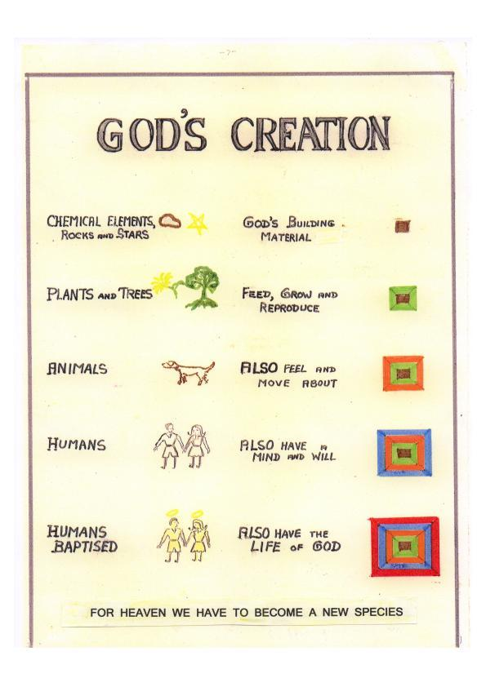

"FOR HEAVEN WE HAVE TO BECOME A NEW SPECIES"

The question now arises, how are we to achieve this higher level of existence? Each person born must acquire it if he is to live his life in eternity as its Creator intended a man should.

It is achieved by BAPTISM, as we know from the books written by men trained to impart this knowledge by the Creator who joined the human race, his own Creation, for the purpose of raising it to the level it had been given, but had lost. The quality of life lost is known as Sanctifying Grace. It prepared men for the Vision of God in heaven.

Four of these men were Matthew, Mark, Luke and John. Their books are called “Gospels”, the ‘good news’. Others wrote letters, among them Peter. Referring to Baptism and its effect on the person baptised,

St.John said: “You have become and truly are, the sons of God…”
St.Peter said: “You are partakers in the divine nature…”
Jesus said: “Unless a man be born again, of water and the Holy Ghost,
he cannot enter into the kingdom of God…”

BY BAPTISM'S sign and formula we are as it were re-born, receiving for SURE by that rite the sanctifying gift, the additional type of life we need, and must have, in order to know and appreciate God in Heaven.

🙞

This initial entry of divine life with the water and words of Baptism is a true act of generation; it sets up a relationship of the baptised to God which could only be that of child to father. We, baptised, are then not merely God’s creatures but his children, bearing his life in us as well as our own, and as such, ‘heirs to heaven’.
“Doing unto others as you would they do unto you” does not make you a Christian. A Mohammedan can do this, or a Buddhist.

Following the teaching of Christ, because it appears to you to be an excellent teaching, does not make you a Christian.

Receiving the life of God, through Baptism, being re-born, makes you a Christian.

🙞

Jesus confirmed the existence and necessity of the Sacrament of Baptism when he commissioned the Apostles, as a final act before His return to Heaven, to go out and teach all nations, baptising them in the name of the Father and of the Son and of the Holy Ghost. [Matt.28:19] He added: “He that believes and is baptised shall be saved, but he that does not believe shall be condemned.” [Mark 16:16]

HOW TO BAPTISE:

In emergencies, anyone can baptise. Pouring water on the forehead of the person to be baptised, at the same time saying:
"Elizabeth Jane, I baptise you in the
name of the Father and of the Son
and of the Holy Ghost:

or in the case of a boy, Hok Nyan, I baptise you in the name
of the Father and of the Son and of
the Holy Ghost"

is all that is required. Elizabeth Jane, or Hok Nyan, is at that moment re-born, receives another type of life, the real life of God. He or she is then a child of God, with the child’s right of inheritance and the dignity of that new plane of life on which to live henceforth.
🙞

The person performing the baptism must have the intention to baptise, but need not himself be a Christian. Provided he intends to do what the Church intends by Baptism, and accompanies pouring the water with saying the words, the baptism is validly conferred. The water must accompany the words because Jesus said, “You must be born again of water and the Holy Ghost”, and the water and words form the visible sign by which we know the invisible effect has occurred. Ordinarily, Baptism is conferred with fitting solemnity by a person appointed to do so.

Full immersion, however customary in the hot lands of Judea, is not indicated. Jesus said to the Eleven: “Teach all nations, baptising them…” His command was universal, yet baptism is unlikely to prove attractive to an Eskimo, invited to contemplate submersion in order to gain the new life.

🙞

EFFECTS OF BAPTISM … Catechism of the Council of Trent, 1687 edition, pp.167-175.

1st By Baptism sin is remitted and pardoned, whether contracted by birth from our first parents, or committed of ourselves.

2nd In Baptism not only sins are remitted but also all the punishments of sins are graciously pardoned of God.”

3rd By Baptism “our souls are filled with Divine Grace whereby we are trained up to be heirs of eternal Salvation."

4th Together with Divine Grace, a "most noble train of Virtues is poured of God into the soul”.
5th By Baptism we are "joined and knit to Christ as Members to the Head."
6th "By Baptism we are signed with a character which can never be blotted out of our soul."
7th Baptism "opens to everyone the gate of heaven, which before was shut."

“By Baptism we are joined and knit to Christ as members to the Head.” (Catechism of the Council of Trent, London, 1687 Edition, p.172.)

What of those who cannot possibly know that Baptism is needed, not having heard of it?

That strong love of God can bring union with God, we learn from Our Lord’s words: “If anyone loves me, My Father will love him, and we will come to him and make our dwelling with him” but there is no outward sign of this happening, no guarantee that one’s love is sufficiently pure.

Apart from this, God is just, and if any man sincerely follows his inner compulsion to do good and avoid evil, we may suppose that God in justice and in accordance with Jesus’ “I will all men to be saved” may grant such a man the gift of life before he dies; but again, there is no outward sign appointed to show that this has happened, no surety that it has.

Ignorance of Baptism is not an advantage. So important a matter should never be left to chance. We can only be sure we have received what we need, by the visible sign of it, BAPTISM. By Baptism we live now in natural state, but linked to God in supernatural state.

FURTHERMORE, it is the basis for all the other Sacraments. Only by becoming members of Christ’s Church by BAPTISM can we ever receive His other Sacraments and thus guard and advance in our Christian life.

Baptism 4th Century

Early Christians were thrilled and delighted with the gift
that Baptism brings. St. Gregory Nazianzus in the 4th century
wrote:

"We call it the Gift, the Grace, Baptism, Unction, Illumination,
the Clothing of Immortality, the Laver of Regeneration, the
Seal and everything that is honourable.

We call it the Gift, because it is given to us in return for nothing
on our part;
Grace, because it is conferred even on debtors;
Baptism, because sin is buried with it in water;
Unction, as Priestly and Royal, for such were they who
were anointed;

Illumination, because of its splendour;
Clothing, because it hides our shame;
the Laver, because it washes us;
the Seal, because it preserves us, and is moreover the indication
of Dominion.

In it the heavens rejoice; it is glorified by Angels…It is the image
of the heavenly bliss.
We long indeed to sing its praises, but we cannot worthily do so.”

(St. Greg.Naz., Oratio 40, 4. Nicene and Post-Nicene Fathers, new series,
vol.vii, p.360.)

Early Christians called the gift received
in Baptism a ‘grace’.

Possessing the gift places one in a ‘state of grace’.

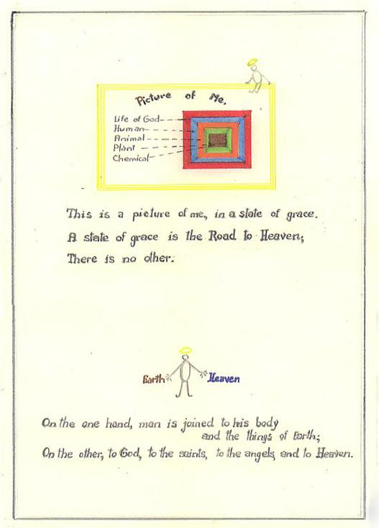
PART ONE – UNION WITH GOD

If the state of grace is broken by mortal sin,
how can it be regained?

- by a prayer of repentance, followed as soon
As possible –

- by the Sacrament of Penance.

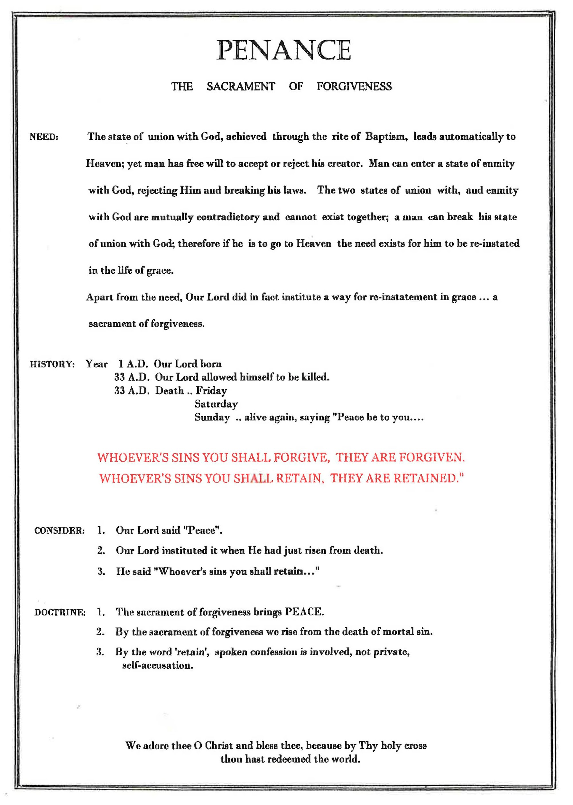

RE-INSTATEMENT IN GRACE … THE SACRAMENT, PENANCE

The word ‘Penance’ carries from its root the meaning of repentance, regret (paenitentia). Christ instituted this sacrament, sign of restoration to life, on the first day of His Resurrection. Significantly, Mary of Magdala, a known sinner who had repented and regretted her former life, was the first person to whom the risen Christ appeared. [John 20: 22-23]

She had come early to the tomb on the third day after His execution and burial, and though it was still dark she could see that the heavy stone sealing it was not in place, the Sanhedrin’s guards were gone, and stooping to look inside she saw that the tomb was empty.

She hurried immediately to Peter and John with the astounding news, and followed as they rushed to the tomb; but after seeing only the winding cloths that had wrapped the dead body of Christ, Peter and John returned home. They had forgotten His words: “Destroy this temple and in three days I will raise it up again.”

Magdalen stayed, standing disconsolate and in tears outside the tomb. On an impulse she stooped again to look inside and there saw two angels in white, one at the head and one at the foot of the place where Jesus’ body had lain. They asked why she cried, and she replied that someone had taken away her Lord and she didn’t know where they had placed Him.

Turning away at that point, she observed someone else present, a man whom she took to be the gardener. “Why do you cry and whom do you seek?” he said, and Magdalen replied, “Oh sir, if you have taken Him, tell me where you have put Him, and I will take Him away.” Jesus, for it was He, just said “Mary!”, and she, “Master!”

He did not permit her to detain him by clinging to His feet as she adored Him, but sent her to the Apostles, “my brethren”, with a message of reassurance; yet indicating a time frame for His stay on earth: “I ascend to My Father and your Father, to your God and My God.” [John 20:17]

Thus Mary Magdalen, the repentant sinner, was the first person to whom Christ appeared after His resurrection from death.

SACRAMENT OF PENANCE: ITS INSTITUTION

The sacred sign by which sin is forgiven was instituted later that Resurrection Sunday, in the evening, when the Apostles were gathered together behind closed doors. Suddenly Jesus was there amongst them, saying “Peace be to you”, dispelling their fear that he was merely an apparition by inviting them to touch and see His wounded hands and feet.

Repeating “Peace be to you”, for that which He was about to do brings peace, He continued: “As the Father has sent me, I also send you”, and breathing on them said:
“Receive ye the Holy Ghost:
Whoever’s sins you shall forgive, they are forgiven;
and whoever’s sins you shall retain, they are retained.”

In these words, Jesus made the Sacrament of Penance. [John 20:19-23]

🙞

Verbal confession is involved by the use of the word ‘retain’. If a man with the power to do so is to impart OR TO WITHHOLD absolution, he must first hear and evaluate the case.

If through true sorrow the sins confessed are to be forgiven, the formula of words that effects this forgiveness is: “I absolve you from your sins in the name of the Father and of the Son and of the Holy Ghost.”

🙞

The need for this Sacrament will always exist given the frailty and weakness of human nature. It is "as necessary to Salvation to those who slip or fall into sin after Baptism as Baptism is (for Salvation) to those who are not yet Regenerated.”

By the existence of this Sacrament we are not left dependent for “Regeneration” and peace of mind on our private assessment, which can be faulty or biased, but on a source external to ourselves, the rite Christ instituted.

SUMMARY:

A CHRISTIAN IS ONE with whom the Creator has shared his life. Baptism is the sign by which he knows he shares it.

This holy life must depart from a Christian if he commits a sin sufficiently grave; but he is still one who has been ennobled by possession of his Creator’s life, and this returns to him, in a sign called Penance or Forgiveness.

He lives again, as he did at Baptism. He has that alone, which will allow him to see God, when his time on earth is over.

I N C I D E N T A L L Y: “If Christ be not risen, our preaching is vain, and your faith is vain. [Paul 1 Cor.15:17]

🙞

The resurrection of Christ is a ‘must’ in Christianity.

Had He remained dead, it would have revealed him to be only man, and not God.

That He did rise from the dead, is reliably shown, historically proved. For forty days after death and burial, He again walked the earth, interacting freely and often with his followers, establishing beyond doubt his resurrection.

No fact in history is so well authenticated.

JESUS DID RISE, OUR FAITH IS NOT VAIN.

[See also page 80 Part 3]

CHRIST APPEARED TO:

Reported by:

Matthew .. 1. The holy women
- 11 Apostles on a mountain in Galilee.

Mark .. 3. Mary Magdalen
- Two disciples, at Emmaus
- Eleven Apostles, before his Ascension

Luke .. 6. He walked with the disciples to Emmaus
- Peter and assembled disciples in Jerusalem

John .. 8. Mary Magdalen
9. Ten Apostles on Easter Sunday
10. Eleven Apostles a week later
11. Seven disciples at Sea of Tiberias.

Paul .. 12. Cephas (Peter)
1 Cor.15:4-8 13. Eleven Apostles
14. More than five hundred people, many of whom still living at time of writing.
15. James
16. All the Apostles
17. Paul himself.

The appearances of Christ after the Resurrection ceased after the Ascension; no more appearances are reported.

APPEARANCES - CHRONOLOGICAL ORDER

Five appearances occurred on the Resurrection Day: the first to Mary of Magdala, early in the morning near the sepulchre; the second to the ‘holy women’ exclusive of Mary Magdalen, a little later, on their way from Jerusalem to the tomb carrying spices to finish the embalming there was no time for at the burial. The third was to Peter alone, later in the day that first Easter Sunday; the fourth to Cleophas and one other disciple, that afternoon on their way to Emmaus. The fifth appearance that day was to ten apostles, Thomas being absent, in the Supper Room where they and their Lord had celebrated the Pasch – last of the Old Testament and first of the New, three days earlier, the previous Thursday evening. It was then He conferred on them the power to forgive sin.

The sixth appearance was a week later in the same room, when Thomas was present and makes his confession of faith “My Lord and my God”. The seventh was on the shores of Lake Tiberias, to Peter, Thomas, James, John, Nathaniel and two disciples, seven in all, soon after the octave day of the Pasch, when they had fished all night and caught nothing. Jesus awaited them on the shore, unrecognised at first. When He advised them to throw the net in on the right side of the ship, they did so and were overcome at the heavy catch they made. On shore, after a meal shared with them, He appointed Peter supreme head of His flock.

The eighth was subsequent to the lakeside appearance, on a mountain in Galilee, to all the apostles, when He gave them the command and the authority to teach the whole world, all that He had taught them, baptising in the name of the Father and of the Son and of the Holy Ghost. The ninth appearance was to the eleven, in Jerusalem when they were “at table”. He promised the coming of the Holy Ghost. [Acts 1:4]

The tenth and final appearance was that same day, when He led the apostles and those with them out of Jerusalem "as far as Bethania" where, blessing them, He left them and "was carried up to Heaven".
🙞

Two other appearances during the forty days of Resurrection, but outside the chronological sequence, are recorded by Paul: to James and to “more than five hundred at once" of whom many were then still living. [1Cor.15:6-7]

That the Mother of Christ would have been first to be made cognisant of His Resurrection, though unrecorded, has been assumed from earliest times..

References: 1st:Jn.20:11-18,Mk.16:9-11; 2nd:Matt.28:8-10; 3rd:Lk.24:34,1Cor.15:5; 4th:Lk.24:13-31, Mk.16:12-13; 5th:Jn.20:19-23,Lk.24:36-43; 6th:Jn.20:24-29; 7th:Jn.21:1-17; 8th:Matt.28:16-19; 9th:Mk.16:14-18,Lk.24:44-49; 10th:^{th} Lk.24:50-53, Mk.16:19.

WHAT DID CHRIST MEAN BY 'BEING BORN AGAIN'?

The LIFE He gives us is quite distinct from the life we secured at birth and is derived from another source. Our very nature is changed and lifted to a higher plane, a plane therefore called supernatural.

The starting point for Christians is the fact that the Eternal Son of God became man. He descended to our level and shared our human nature by His human birth, that He might lift us to His level and enable us to share His nature by a supernatural birth. In Him, God is given to us that we may become one with God. And as surely as His human life enabled the Son of God to live and experience our life in this world, so by our rebirth into the Christ-life we are to live and experience the life of God through grace in this world and through glory in heaven.

It is obvious that such an experience is proper to God and not to man, just as an intellectual life in this world is proper to man and not to a tree. A tree would have to be elevated far above its natural life to be able to converse with man and share in man's activities. The human level would be supernatural in comparison with the level of mere vegetation.

Far more is the God-level supernatural in comparison with man's level. For us to live the life of God, to know as He knows, love as He loves, and be happy with His happiness, we certainly will need a new principle of life, and new powers which are beyond those got by natural birth. And Christ communicates that new life to us by a baptismal rebirth which enables us to share in the Divine Nature, and gives a thought, love, action, and destiny in common with God. And we receive the principle of that life by the Sacrament of Baptism in which we are born again of water and the Holy Ghost.

That life is in us by grace as the life of the oak tree is in the acorn; and it is that life of grace which will attain its full development and perfection in the glorious life of eternal association with God in heaven itself under conditions infinitely above the natural conditions of life in this world.

THAT IS WHAT CHRIST MEANT WHEN HE SAID "YE MUST BE BORN AGAIN."

🙞

END PART ONE - UNION WITH GOD

THE BIBLE, HISTORY OF REDEMPTION

Aim: To help students appreciate the progression from the things we see, to:-

THE BIBLE, HISTORY OF REDEMPTION

Orientation: WE CAN SEE:-

(i) MAN and the things about him

(ii) HE SEES EVERYTHING WORK BY LAWS:-

* Scientists study Laws

* Wasps follow Laws

(iii) HE CAN SAY:-

* There must be a Lawgiver
OR
* It just happened.

LAWS

A LAWGIVER

CHANCE

OR

IF HE SAYS: "The world happened by chance",
no evidence supports this view.

Doctrine: IF HE SAYS: "Laws? Therefore a Lawgiver",
there is a book that supports this view,
a book thousands of years old

THIS BOOK IS THE BIBLE
ORIENTATION: “Insects follow laws.” (Ross, ‘History of Entomology’, c. 1933.)

THE NON-SOCIAL OR SOLITARY WASPS produce and secrete in their bodies a marvellous substance which, injected with their sting into their selected prey, causes complete motor paralysis, without death resulting. On this insect prey, one egg is then laid.

This induced paralysis has a three-fold advantage for the larva that will hatch from the egg;

1. it keeps the prey fresh and edible until the larva hatches and begins feeding;

2. it ensures that the prey will not move away from the helpless wasp larva;

3. it prevents attracting scavenger insects to the odour of a dead insect.

The various wasp groups are usually specific in the prey that they choose for their young to feed on; some use caterpillars, some use spiders. One, of the super-family Sphecoidea, Specius speciosus, uses the common cicada. Attacked by the wasp, the cicada makes a loud piercing noise, which dies away as the paralysing venom takes effect. The wasp then carries the cicada to a burrow it has already prepared in the ground; an egg is deposited on the body of the prey; the wasp seals the burrow and departs, to seek other cicadas on which to lay other of its eggs. It usually dies soon after, its life cycle completed.

In two weeks or so, the young wasp grub hatches, and feeds upon the cicada. It grows to full size, spins a cocoon for itself, lies dormant in it sometimes all winter and spring; but when it emerges, a perfect wasp, it follows out the exact life cycle of the parent.

Thus we observe the adult wasp providing means of sustenance for a generation it will never see, and a new generation following with undeviating precision a life pattern it has never known.

🙞

See also V.Rev.M. Sheehan, D.D., Apologetics, Part 1, Dublin, 1950, pp.15, 16. "Natural Apologetics, The Existence of God."

NOTE: Sept.1996 TV: The recent computer recreation of man from earliest skeletons indicates that man must have walked upright, never crouched or walked with bent knees.
THE BIBLE

THE BIBLE is a collection of books thousands of years old; contains the story of a group of men distinct and unique, differing from all other men in that they alone guarded the idea, not of many gods, but of one God, living and a person, though unseen; the Creator and Lawgiver, designing an ordered universe to be the background, and give subsistence to, a being made ‘in His own image and likeness’; and the Creator’s own nature being non-material, the human’s material self, his body, was allied to a non-material and therefore non-corruptible principle, his soul.

This creature, man, was not an automaton, unable to do other than obey his Creator, but possessed free will, and was able to choose whether or not to live in harmony with his Creator.

The Bible relates the creation of intelligent beings other than human, non-material but also possessing free will, angels. With free will, there comes a moment of test, when the possessor makes a choice of one way or the other, and some angels chose to reject the dominion of God, saying ‘I will not serve’.

The creature, man, and the ‘woman’ fashioned from him, also chose to reject God. The gravity of their act, equivalent to the angels’ ‘I will not serve’, changed them. They felt themselves ‘naked’, and hid from God.

Their freely-chosen enmity to God, their freely-decided proud aim to ‘eat of the tree of knowledge’ and so gain more knowledge than God wished them to have, since He expressly forbade them to ‘eat of this tree of knowledge’, broke their liaison with God. The serpent’s insidious ‘Eat…you will become as Gods’ found a ready response in their hearts, but having followed it, this course was not the one of happiness mapped out for them. They were excluded from the garden of Eden, and did not know how to regain it.

But God promised that a descendant of the woman would crush the head of the one who led her to seek the status of God for herself and her man. [Gen.3:15]

DOWN THE AGES, the fortunes of this unique people rose and fell; until the time approached when the chromosomes of man and the act of God in her soul should produce the perfect, sinless creature, Mary, while external events shaped themselves to a climate where reparation would be offered to God, the redeeming of man effected and the promise of God, kept.

This time was about the year 734 A.U.C. Romans occupied the City of Jerusalem and the Jewish people under Herod the Great kept allegiance to the one, personal God. The Jewish child Mary was born and grew to about the age of sixteen years, consecrated to God’s service and now espoused to JOSEPH, of the line of King David, but not yet married, indicated by her response to the angelic message that she would bear the Messiah: “How can this be done, since I know not man.”

The Bible, its whole tenor, its whole content, underscores from the beginning the shaping of two linked events, the INCARNATION and the REDEMPTION – the Incarnation, God taking on human flesh, and the Redemption, God in human flesh offering himself in sacrifice, thus adequately repairing the break with God which man of his nature was powerless to make…only God could make reparation to God.

Of the virgin, Mary, God took flesh, and coming to birth, was named Jesus, in Hebrew ‘Saviour’. He grew to the age of thirty years, then began to preach a spiritual message, the ‘New Law of Grace’. He set aside at times the natural law, multiplying food to feed the hungry, healing instantaneously the sick and three times bringing dead people to life, one of them, Lazarus, having been dead four days.

He made enemies; they killed him.

Dead and entombed for over thirty-six hours, he arose and spoke again on this earth, but with the signs of his death upon him, nail marks, a spear wound.

Again, after forty days, he left them and the earth. Before the eyes of the watching disciples, as a sacrifice is offered to God he rose upward until lost from sight in the clouds of Heaven. He had made a society to teach his word and carry on his work: His Church, the Rock from which alone springs the water of eternal life. [Numbers 20:8; John 4:14]

"But the water I will give him shall become in him
a fountain of water, springing up into Life Everlasting."
[John 4:14]

Old Testament: "and when Moses took the rod as the Lord had commanded,
and struck the rock…there came forth water in great abundance."
[Numbers 20:6-11]

Christianity - part two

Part two - perfection

“The divine work begun in Baptism should have continuing growth until it comes to final
perfection in the glory of Heaven.” Marvels of Grace, Preface, Gauthier of Montreal.

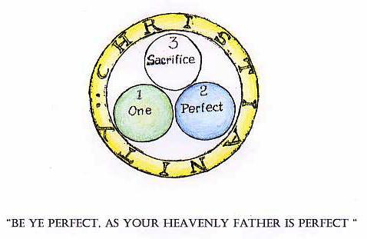

‘SUPER-NATURAL GRACE’ - The means of growth
“The divine work begun in Baptism should have continuing growth until it comes to final Perfection in the glory of Heaven.”

Supernatural or Sanctifying Grace, which when received gives man an affinity to God, in soul not in body, is a quality so marvellous it defies description. Nevertheless attempts are made.

St. Thomas of Aquin compares the sanctifying gift received in Baptism to the action of fire on iron in a smith’s forge, its dullness and rigidity transformed into glowing heat, lustrous and malleable. ‘While preserving its own nature, the iron to all appearances identifies itself with the fire that permeates it through and through’.

St. Basil likens the soul in grace to a crystal ball in the sun, absorbing light and heat and reflecting them in all directions.

🙞

The Council of Trent in its Catechism states: “But Grace…is not only that by which we have remission of sins, it is a Divine Quality inherent in the soul, a kind of Splendour and Light which makes our souls more beautiful and glorious.”

🙞

“It is common teaching of Catholic Theologians that in order to be capable of enjoying the Beatific Vision the soul must first be given the ‘lumen gloriae’, the light of glory, there being such a huge disproportion between the joys of Paradise and our ability to enjoy them.

The ‘light of glory’ is the term they give to the efflorescence, or bursting into flower, of the sanctifying grace with which the soul left the world. They hold also that the degree of happiness enjoyed will be in proportion to the amount of sanctifying grace of which we die possessed.”

_{T}he gift of life that Baptism brings is a living gift, it grows.

Christ Our Lord made ways for it to grow.

The extent to which the Life of God expands in us on earth is the extent to which each individual will know God in Heaven.

THE STORY OF THE LADY AND HER ROBE FOR HEAVEN

Orientation
Once there was a lady, who died and went to Heaven; and they measured her for the robe she would wear, for it had to be just her size.

So they took her measurements, and eventually brought her the gown. With delight she anticipated the graceful flowing robe that she would wear through all the years of Heaven; she could hardly wait to see it.

But what did she see, when at last they brought it to her, but a plain ugly dress, skimped and unadorned. She was so disappointed she could have cried.

"Why have you brought me this thing? Where is my lovely dress that I'm to wear in Heaven?" she said, and they replied,

"We are very sorry, Madam, but that was all the material you gave us."

∗ ∗ ∗
Consider
1. She did not, during her life on earth, prepare herself for her life in Heaven.

2. She had not used the ways Our Lord made for her to grow in grace.

3. She could have had a magnificent dress if she had used them.
Doctrine

1. Our Lord wants us on earth to prepare ourselves for our life in Heaven.

2. He wants us to use the ways He made for us to grow in Grace.

3. Our Lord said "Be ye perfect, as your Heavenly Father is perfect."

[Matt. 5: 48]

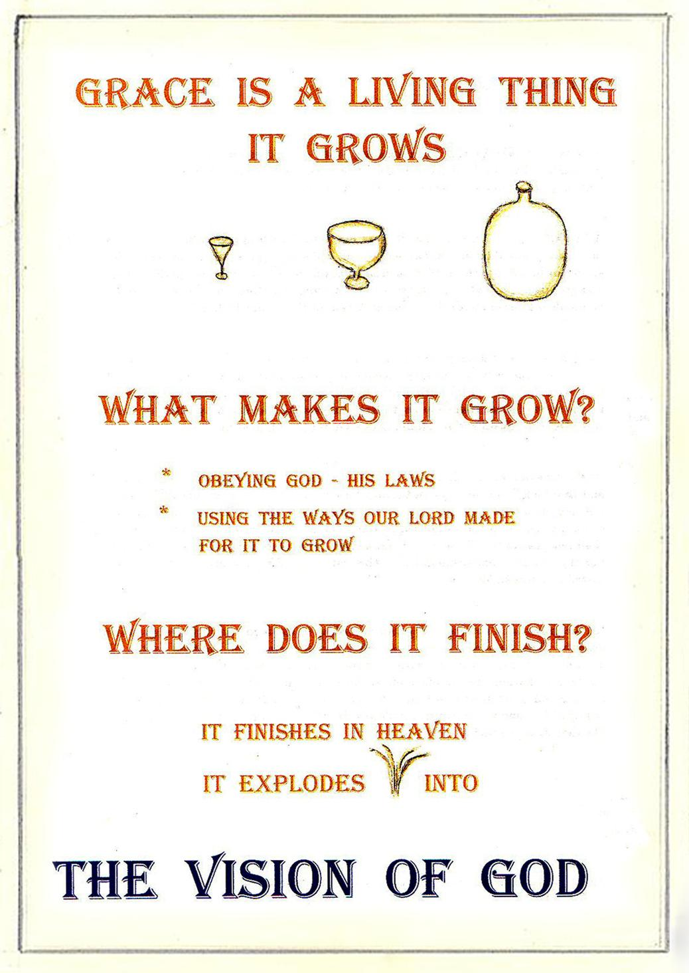

PART TWO: PERFECTION

ATTAINING HEAVEN BY A TRUSTING STATE OF FAITH ALONE, is the antithesis of possessing a living gift that is the life of God, and can grow and increase, giving ever-widening power to know the limitless God in Heaven.

A blanket reward, uniform for all, does not accord with a) free will, for one person may strive more than another to please God, and so achieve a greater reward, a higher status; or b) the operation of the sacramental life, which can augment perfection in us and give us in the end, a greater power of knowing and absorbing the beauty of God. c) nor does it accord with the nature of the gift of Baptism, which is dynamic.

So opposed to one another are a state of grace and a state of sin, that they cannot exist simultaneously in the same person, any more than fire can exist with water, light with darkness, or life with death. Where a grave state of sin is entered and lived in, the state of grace that comes with Baptism departs, and it is only with this that we enter Heaven. Justification, attaining heaven, is not certain or inevitable.

Paul’s direction to the Christians in Philippi was: “Work out your salvation in fear and trembling” and to those in Corinth he wrote: “I chastise my body and bring it into subjection, lest perhaps when I have preached to others I myself should become a castaway." "He that thinks himself to stand, let him take heed lest he fall." "The unjust shall not possess the kingdom of God; neither fornicators nor idolaters nor adulterers nor the covetous nor drunkards.” The state of justification arrived at by Baptism therefore is forfeitable.

All life grows, and not uniformly, but according to the food and facilities given it for growth. The numerous terms describing the new status of Baptism in the New Testament all express it as a form of being: “a re-birth in God, a new kind of existence, sharing the divine nature, sons of God born of God, born again of incorruptible seed, temple of God, the spirit of God dwells in you.”

Life is not static but dynamic, and the extent to which this life of one-ness in God can grow is infinite, like the infinity of God.

Phil.2:12; 1 Cor.9:27; 1 Cor.10:12; 1 Cor.6:9-10; Pet.1:4; 1 John 3:2; 1 John 3:9; 1 Pet.1:23; 1 Cor 3:16

So, if John dies with a ‘wineglass’ full of grace, he will have a ‘wineglass’ full of happiness in Heaven.

If Jane dies with a huge ‘chemists’ bottle’ full of grace, she will have a huge ‘chemists’ bottle’ full of happiness in Heaven.

Will Jane be happier than John?

No. Each will be perfectly happy, because each will have all the happiness he or she can hold. Each is full of happiness. YET, Jane having a greater amount of grace than John, will have a greater amount of happiness. (A huge bottle full of water is not more full of water than a wineglass full of water; but it does hold more.)

John will not be envious of Jane, because he will clearly recognise that Jane deserves and earned all that happiness, and that he himself has all that he can hold.

🙞

Note: This passage is adapted from U.S.A., F.P. Le Buffe S.J., “Let’s Look at Sanctifying Grace”.
PART TWO - THE SACRAMENTS
POWER
STATION
Electricity
Switch
X
Machine

GOD

Life of God
X
Sacraments
US

CHRISTIANITY Part Two: PERFECTION

THE SACRAMENTS: WAYS INSTITUTED BY CHRIST for the presence of God in us to increase:-

At the start of life, a sacrament of initiation .. baptism
As life develops, a sacrament of forgiveness .. penance
a sacrament of union .. eucharist
sacraments for the states of life .. confirmation
.. matrimony
.. holy order
.. last anointing

All seven Sacraments add spiritual powers to the soul, enabling man to take part in the worship of God in accord with the rites of Christian life, sharing the priesthood of Christ, but three of them, Baptism, Confirmation and Holy Order also imprint on the soul of the recipient an indelible identifying mark.

Baptism and Confirmation give power to receive the other Sacraments. Holy Order gives power to confer the Sacraments on others.

THE SACRAMENTS: SEVEN WAYS TO PERFECTION

1. "AT THE START OF LIFE, a Sacrament of Initiation .. Baptism."

Life that has been created, we know; but there is also life that has not been created, yet exists, that of God.

God is the substance, we are the shadow.
He the voice, we the echo; yet by Baptism we share His life.

Life-sharing between two such disparate natures must take the form of a link forged between the vast uncreated life of God on the one hand and the finite yet 'God-like' soul of man on the other.

Man's 'God-like' soul, that is, his faculties of intellect and will, in which he is made to the 'image of God', is transformable, by the coming of a gift from God that links man's soul to him in life-sharing union.

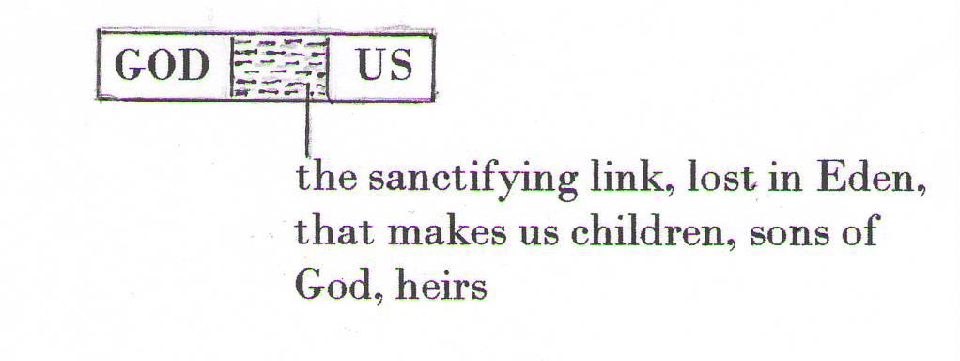

THIS LIAISON HAS ANOTHER PURPOSE; that by it the Holy Trinity of God may come and dwell in us; make us its abode. We become the place where God dwells, able henceforth to be transformed to the image of Christ. "You shall be holy, for I am holy." [Lev.xi:46 and 1 Pet.i:16]

God Himself comes with the Gift of His Life to dwell in us; and the moment of His coming is Baptism.

🙞

"ABIDE IN ME; AND I IN YOU. YOU ARE THE TEMPLE OF GOD; THE SPIRIT OF GOD DWELLS IN YOU. WE, GOD THE FATHER AND THE SON, WILL COME TO HIM AND MAKE OUR ABODE WITH HIM."

1. BAPTISM RAISED TO THE STATUS OF SACRAMENT:

To Nicodemus, Christ had said: I say to you solemnly, unless a man is re-born of water and the Holy Ghost, he cannot enter into the kingdom of God. That which is born of the flesh is flesh; and that which is born of the Spirit is spirit. Wonder not that I said to thee: You must be re-born.
[John 3: 5-7]

The baptism of Christ in the River Jordan by John the Baptist marked the beginning of Christ's public ministry. It showed His approval of John's having baptised with water and of John's work to lead men to Him, and sanctified baptism by accepting baptism Himself.

At the baptism of Christ, all Persons of the Holy Trinity were present. God the Holy Ghost, in the form of a dove, rested over the head of Christ, God the Son; the voice of God the Father was heard saying: "This is my beloved Son in whom I am well pleased." Heaven had become closed to men by Adam's sin, but now would be open again to man by Baptism.

Baptism was instituted as a Sacrament at the moment Christ allowed Himself to be baptised by John, but it was only to become operable after His sacrificial death and resurrection had secured man's redemption and He had ordered his Apostles, immediately before his Ascension to Heaven, to teach all nations, baptising them in the name of the Father, and the Son and the Holy Ghost.

🙞

2. “AS LIFE DEVELOPS, a sacrament of forgiveness, Penance” [see pages 12-16, Part One]

Man’s freewill and his lowered human nature together demand that the link between himself and God made at his baptism almost certainly be broken; hence the necessity for a Sacrament of Forgiveness.

Early Christians seldom used this Sacrament, for grave sin was rare, and then only in the sense for which it is strictly needed, for mortal, life-killing sin. But some time after the fourth century ‘devotional’ confession of venial sin as well, and of previously confessed and pardoned mortal sin came to be practised, became widespread, and has continued to the present day.

‘Devotional’ confession arose as awareness became deeper of the graces in the sacrament of Penance, and of its power to strengthen and perfect the will.

🙞

3. EUCHARIST - SACRAMENT [see pages 40-47]

4. CONFIRMATION .. A SACRAMENT OF INITIATION COMPLETED

Just as in the natural order a man is born to grow to manhood, so the Divine Life born in us at Baptism is to deepen into full maturity, through the Sacrament of Confirmation. In Confirmation the gifts of the Holy Ghost received at Baptism are conferred in a fuller, more perfect form. It confers a special, indelible character on the soul and is received only once. Unlike physical maturity's slow growth, Confirmation confers spiritual maturity in an instant, in fullness, with the administration of the sacrament.

Confirmation is not a first necessity for salvation as is Baptism; nevertheless Christianity is a way of life, a divine way of life, and as all in the natural order proceed from birth to maturity, all the baptised are meant to hold their Christianity in this fullest degree.

🙞

ITS INSTITUTION: The Lord, after his Resurrection and just before his Ascension, promised the remaining eleven Apostles that the Holy Ghost would come to them. "You shall receive the power of the Holy Ghost coming upon you; you shall be witness to me in Jerusalem, Judea and Samaria and even to the uttermost part of the earth."
[Acts 1:8]

That promise was fulfilled ten days later, on the day called Pentecost, fiftieth day after the Resurrection, when all including the newly elected Matthias were gathered together in one place. The Holy Ghost came to each of the Apostles and those present with them, in visible form like a tongue of fire on the head of each. From that moment on, strengthened, they faced with courage the work they had feared.
[Acts 2:1-4]

🙞

That all the baptised are meant to receive also Confirmation is shown in Peter's first public address, given immediately afterwards to the people of Jerusalem who had asked "What shall we do?" Peter said to them: "Do Penance and be baptised, every one of you, in the name of Jesus Christ for the remission of your sins, and you shall receive the gift of the Holy Ghost; for the promise is to you and to your children and to all that are far off, whoever the Lord our God shall call."
[Acts 2:38-39]

🙞

It was in a different rite from that of Baptism that the Gift of the Holy Ghost was conferred by the Apostles, seen the first time they are mentioned giving the Sacrament of Confirmation: "When the Apostles who were in Jerusalem heard that Samaria had received the word of God, they sent Peter and John to them; who when they had come, prayed for them that they might receive the Holy Ghost, for He was not yet come upon any of them, but they were only baptised in the name of the Lord Jesus. Then they laid their hands upon them, and they received the Holy Ghost."
[Acts 8: 4-17]

Moreover, the conferring was done by Bishops, Peter and John. These Samaritans had already been baptised by Philip, a deacon; yet it was Peter and John who came to administer the Confirmation, though they came at the risk of their lives in that time of persecution.

CONFIRMATION .. the Rite

The Confirmation rite the Apostles used was a ‘laying on’ of hands, with prayer. Anointing with oil as to a Priesthood, a higher rank, was included, the oil used being Chrism.

3rd Cyprian, a Bishop who died in 258 A.D., wrote a comment on the foregoing Gospel
Century passage, and in so doing revealed the use in the third century of Confirmation as a Sacrament:

“The Samaritans, who had already obtained legitimate ecclesiastical Baptism, did not
require any further Baptism. Peter and John merely supplied what was wanting, namely
that by prayer and the imposition of hands the Holy Spirit should come down upon them.
This is also the practice with us: those who are baptised in the Church are presented to
the Bishops, and through our prayer and the laying on of hands, they receive the Holy
Spirit and are made perfect by the seal of the Lord.”

5th And Augustine, a Bishop who died in 430 A.D., shows the faith of the fifth
Century Century and the practice of Confirmation then, writing: “The Sacrament of
Chrism is one of the visible signs, and like Baptism itself is most holy”.

21st The formula used today by the Bishop in conferring the Sacrament is, with the
Century laying on of hands and tracing with Chrism the sign of the Cross on the forehead:
“I sign thee with the sign of the Cross and I confirm thee with the chrism of
salvation in the name of the Father and of the Son and of the Holy Ghost.”

🙞

Whether administered straight after Baptism as in early Christian days, or held back for a period of years as now, Confirmation advances us immediately to the higher level of Christian living, a level of closer union with the divine Life and Presence.

The intellect will now be attracted to dwell with pleasure on the beauty, the majesty, the infinity of God; to grasp the truth and hold it in our minds; to turn away from things and people detrimental to our eternal welfare; to see the hand of God in the world and all creation, but to love and use these only in so far as they lead us to God.

The will through Confirmation is strengthened to profess, not hide, the Christian way of life and to defend its beliefs to the point of death; to serve God in prayer and worship, seeking Him often in His sacraments; and to prudently realise the power of God and as favoured sons, fear to offend Him.

The purpose of the coming of the Holy Ghost in Confirmation is to assist us to grow ever more in likeness to Christ; and ever more truly reflecting to Him that image, God may say of each of us too: “This is my beloved son.”
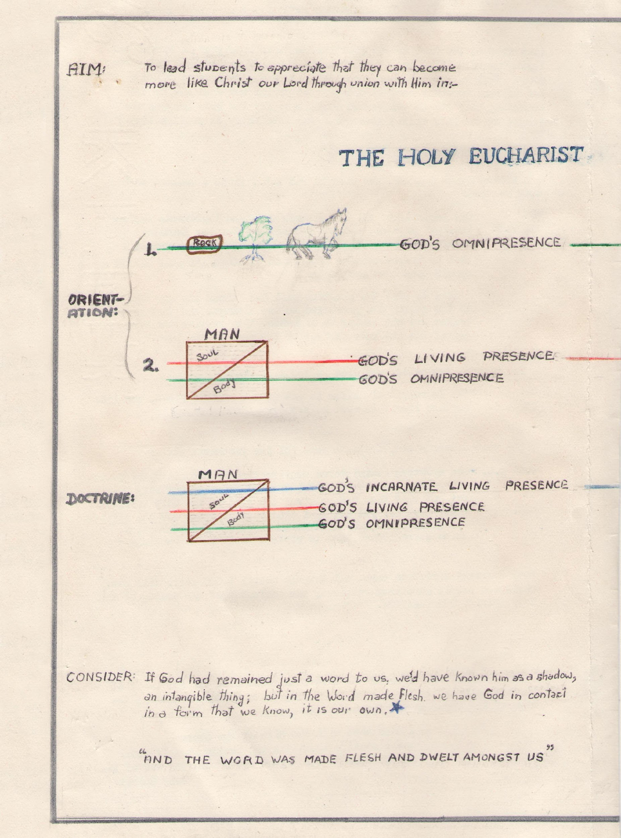

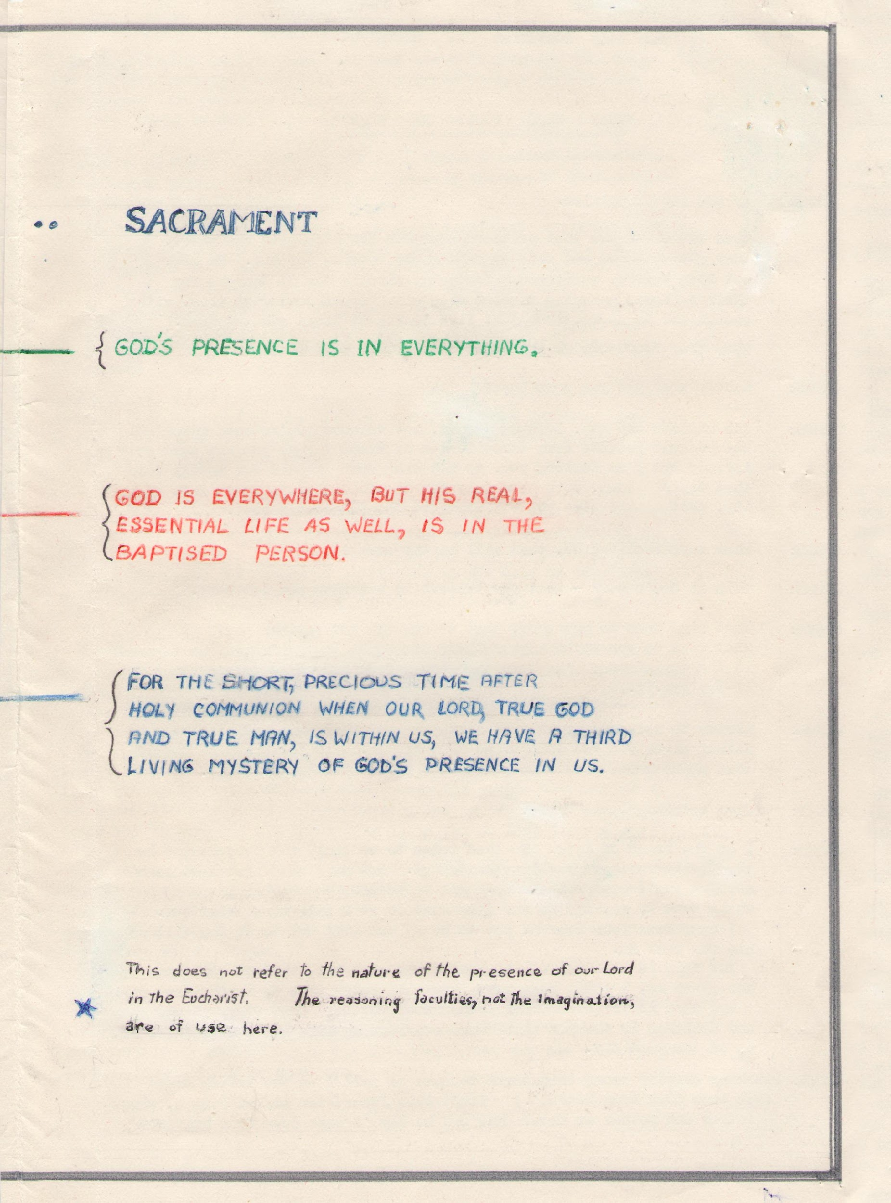
3. THE EUCHARIST-SACRAMENT, ANNOUNCED [John 61:1-70]

SCENE:

JESUS:

CROWD:

JESUS:

CROWD:

JESUS:

CROWD:

JESUS:

CROWD:

JESUS:

By the Sea of Galilee And the next day, in the Capharnaum synagogue

Jesus had just crossed the inland sea and is sitting with his disciples on a grassy mountainside. He had done many miraculous cures, and a huge crowd, numbering five thousand, had followed him there. He asked Philip where bread could be obtained to feed them all, knowing of course what He was about to do. Philip answered that two hundred penny worth would hardly be enough, but that five barley loaves was all they had and two fish. There ensued the miracle by which all five thousand were fed, with plenty left over, from just the five loaves and two fish.

The crowd began to acclaim him as the Messiah all were expecting, and would have made him their king then and there, but He fled alone into the mountain.

By evening Jesus had not returned, and the disciples went down to the shore and re-embarked to return to Capharnaum, the crowd observing that they went alone. They had barely gone 30 furlongs, in windy and rough conditions, when they saw Jesus drawing near their boat walking to them over the sea. They were terrified at the spectacle, but saying “It is I: don't be afraid”, He joined them in the boat.

Next day at Capharnaum the crowd arrived in other ships, seeking him and expressing their amazement to see Him already there. Jesus then reminds them of the miraculous loaves that had satisfied their hunger the day before, and uses the opportunity to introduce the subject of an eternal food.

Don't strive as much to obtain ordinary food, as to food that endures unto everlasting life,
that I, the Son of Man, on the authority of God the Father, will give you.

What should we do then, to obtain this food?

You must believe in Me, whom God the Father has sent.

We need a sign, to help us believe. Our fathers in the desert had manna sent them.

The bread that Moses gave was not the true bread from Heaven that gives life to the world.

Then give us this true bread, Lord.

I am the Bread of Life. He that comes to me shall never hunger, and he that believes in me shall never thirst. I came down from Heaven to do the will of Him that sent me, not my own.

The crowd by now has begun to murmur against his having said he "came down from heaven".

Isn't this Jesus the son of Joseph, whose father and mother we know? How can he say
"I came down from heaven?"

Don't murmur among yourselves. I am the bread of life. Your fathers ate manna in the
desert and they are dead. I am the living bread that came down from heaven, and he that eats of it shall live forever. And this bread that I will give you is my flesh, for the life of the world.

The crowd now begins disputing this among themselves.

CROWD: How can this man possibly give us his flesh to eat?

Far from withdrawing his statement, Jesus repeats it more strongly:

JESUS: I repeat: UNLESS you eat the flesh of the Son of Man and drink his blood you shall not have life in you. He that does, abides in me and I in him, and I will raise him up on the last day.

JESUS SAID THESE THINGS, TEACHING IN THE CAPHARNAUM SYNAGOGUE
IN THE FINAL DAYS BEFORE HIS DEATH.

Even among his disciples, many are disturbed.

DISCIPLES: This is a hard saying. Who can believe it?

JESUS: (foreshadowing both his Resurrection and Ascension, and to correct their obvious impression of a carnal eating and drinking) This scandalises you? Yet you will see the Son of Man ascend,
to where he was before. The spirit gives life, the flesh is nothing. My words are spirit and life, but some of you still do not believe me.

And many walk away, never to return.

JESUS: (to the twelve, giving them also the choice) Will you also walk away?

SIMON PETER: Lord, to whom shall we go? You have the words of eternal life, and we have
believed and have known, that you are the Messiah, the Son of God.

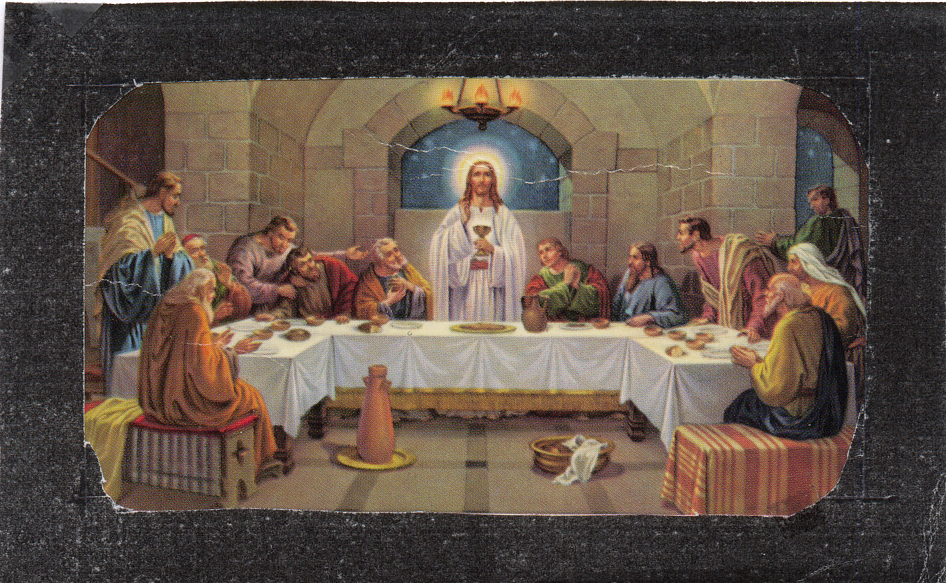

Above, Leonardo da Vinci (1452-1519) depicts the implementation of His promise. Men would now be able to shoulder the Cross He would next day accept on their behalf. [See also pages 72,75-78]

3. THE EUCHARIST: Sacrament of Union - Christ and all Christians

PROMISE FULFILLED: These are the words in which Jesus made his promise come true; the promise that He was the bread of life, and if anyone ate this bread, he would live forever:

The night before he died, at a supper in Jerusalem with his chosen apostles, taking bread He blessed, broke and gave it to them saying:

“Take ye and eat, for THIS IS MY BODY” and taking the chalice of wine, He gave thanks, then gave it to them to drink saying:

“Drink ye all of this, for THIS IS MY BLOOD of The New Testament,
which shall be shed for many unto remission of sins” [Matt 26:26-28]

On this last Paschal meal of the Old Testament Jesus established that of the New Testament.

🙞

Manna: The crowd, page 44, were referring to the amazing food that fed their forefathers in the desert, where for forty years they wandered in search of the Promised Land. Every morning with the dew on the ground appeared also bread, that they came to call Manna.

It was small, and as if beaten with a pestle. Pearly white in colour, it looked like hoar frost covering the ground, and tasted like flour and honey, or like bread prepared with oil, when cooked.

Each day they had to gather just enough for each family for the day. If they gathered any more it went bad; and on the sixth day of each week, they gathered enough for two days, for none fell on the seventh day, the Sabbath. [Exodus 16:13-35, Numbers 11:7-9]

-2-

Christ is not present in the consecrated bread and wine of the Eucharist in the way a body is present in space. It is not a quantitative presence. The nature of his presence in the Eucharist is a deep mystery. We can only believe his word that it is so. No change that we can see, occurs; and yet the substance or reality of bread becomes the substance or reality of His body, and the substance or reality of wine becomes the substance or reality of His blood, really truly and actually there, supplanting the substances of bread and wine, and separate as in the death on the Cross.

The accidents, sense-perceptible qualities, such as the whiteness of the bread, do not become the whiteness of Christ’s body; nor the redness of the wine the redness of His blood. The senses recognise ‘accidents’, a term for something that has no existence on its own, such as bread’s whiteness, or its taste; but only the mind knows ‘substance’, a term for the reality of a thing, that which it is, such as bread. When the words of the Eucharist are said, only the substances, the reality of bread and wine, that which they are, are changed, are no longer there, and the substance of Christ Glorified, is there. [Trent, p.208]

🙞

For as long as the ‘accidents’ of bread and wine remain intact; as long as they exist as such without breaking down or corrupting, such as by the chemistry of the body when they are consumed or by the action of the atmosphere if they are retained for a long period, for so long is the substance of the Body and Blood of Christ, Christ Himself, there, and we may, and are commanded to, unite ourselves to Him in His sacrifice, by consuming His Body, His Blood, or both.

In Holy Communion, under the action of the normal bodily processes, the Body of Christ will remain for about 30 minutes, after which, by disintegration of the accidents of bread or wine, His Body and Blood, HE, is no longer there. But a union in love, in spirit, endures.

🙞

Christ was living when he consecrated the bread and wine, and He is living now, in glory in heaven. It is not possible for a body’s flesh and blood to be separate while still alive, and Christ, living, whole and entire as He is now, is present in either the Body or the Blood, or both, so that in receiving either or both we receive the living Christ. Only the priest celebrating the Holy Eucharist need follow the whole rite, receiving the Body and the Blood of Christ.

-3-

Sacramental signs always accompany the imparting of new life to the soul, its rise to another status, its reception of new powers, so that it can be seen and known that something invisible has nevertheless occurred.

Sign and The sign in the Eucharist, Sacrament, of the invisible working of the new life, is food partaken,
Effect to signify the transformed soul's life maintained and growth nourished. As manna was the daily bread of all the Israelites in the desert, so is the Eucharist the 'living bread' to nourish all the people of God in the New Law in which Christ is the New Adam, from whom all must be spiritually descended who hope for eternity with Him.

Fact Two differences of effect between the food of nature and this food for the Spirit: the one causes the body to grow, but within the limit imposed by circumstances and the inherited structure, whereas growth of the new life of the spirit has no limits, for it grows to conformity with the Infinite. Again, the body in absorbing bodily food converts it to likeness to itself; while the 'bread of heaven', its strength and power contrasting with our weakness, absorbs us and converts us to likeness to Itself. Receiving the Holy Eucharist means growth without limit, in likeness to Christ.

Pledge The union of ourselves and Christ in the Eucharist is substantially the union that will be ours with Him in Heaven, and it is a pledge of it, for Christ promised, [John 6:59] "He that eats this bread shall live forever." As He has said so, we may expect it will be so.

Precept Conversely, Christ's words are 'unless you eat the flesh of the Son of Man and drink his blood you shall not have life in you." [John 6:54] Account is taken of the admonitory precept contained in these words, by receiving the Holy Eucharist at least once a year, and within a time limit, to show observance. (Note: 'Son of Man' was one of the current titles for the Messiah, the one awaited.)

🙞

As stated previously (page 45), in announcing the coming Sacrament, the Lord saw that his words were not being understood in the sense he used, of his living body, but were being taken to mean his dead flesh and blood to be eaten and drunk. He corrected the wrong impression, making it clear, that that which his words proposed to them was characteristically life and spirit; body and blood shown separately for a purpose yet to be revealed.

He spoke of his Ascension, which would demonstrate his Divinity and his Power to carry out the assertions he had made, and would let them know his body was not to be left on earth to be divided and consumed in the gross manner they supposed. [John 6:63, 64]

Still many disciples left him, and as then, so today this is the point where many leave Him.

-4-

Christ’s words of institution contain no symbolism. ‘This is my body; this is my blood’; and were understood in their literal meaning for sixteen centuries with only a rare dissentient. The Apostle Paul’s words show that they were taken then in their obvious sense:

“Whoever shall eat this bread or drink this chalice unworthily, shall be
guilty of (desecrating) the body and blood of the Lord.

For he that eats and drinks unworthily, eats and drinks judgment to himself,
not discerning the body of the Lord.” [1Cor 11:27-9]

The Holy Eucharist, as a sacrament for strengthening the spiritually living, is approached only in a state of grace; and afterwards due and proper thanksgiving is made, in time spent in recollection and prayer. “Six Sacraments give the grace of God, but the Eucharist gives God Himself.”

🙞

There is a deeper aspect of the Holy Eucharist, the exposition of which falls more
naturally in Part 3 – SACRIFICE. (Pages 68-79)

5. SACRAMENTS FOR THE STATES OF LIFE .. MARRIAGE.

Marriage in the time of Christ was corrupt. He restored it to the original purity of God’s design and raised it to the dignity of a sacrament.

Among both Jew and Gentile, divorce had been permitted and polygamy tolerated. Christ re-stated the plan of creation, “He who made man from the beginning made them male and female, not two flesh but one.” And added “whom God has joined together let no man put asunder.” [Matt.19:4,6] These words mean that a man and woman once married to each other must remain so.

Christ declared the law of Moses and the patriarchs ended with John the Baptist. “The law and the prophets were until John. From that time the kingdom of God is preached.” [Luke 16:16]

Union, the source of our life, is sacred, as is the union of the divine with human nature that is Christ, and the union of Christ and us that is Christianity.

Because the union of Christ and us is an exclusive and lasting union, source of our ‘above-natural’ life, it is symbolised by the exclusive and lasting union of man and woman, source of our natural life. This being so, the words of Paul, Apostle are quoted as revealing that Christ made of the Christian Marriage Contract a Sacrament, productive of the day to day graces, channelling the life of God.

[Paul: Eph.5:24-30] "As Christ is head of the Church, so is the husband to the wife. As Christ loved the church, so let husbands love their wives. Christ gave himself up for the Church, that he might sanctify it, cleansing it by the washing of water in the word of life, to present it to himself a glorious Church, without stain or wrinkle or any disfigurement, holy and without blemish.

In the same way ought men to love their wives as their own bodies. In loving his wife a man loves himself, and no man bears ill-will to his own flesh. He nourishes and cherishes it, as Christ does the Church; because we are members of his body, of his flesh and of his bones."

-2-

The words of the marriage contract are:

I take thee as my lawful wedded wife.
I take thee as my lawful wedded husband.

In speaking this contract, to which inward consent must be given as well, the Christian man and woman confer the sacrament on each other, and its grace begins the moment the words are said. The husband and wife have administered to each other the sacrament of marriage.

The contract, understood as being of one man with one woman, for life, for the purpose of marriage union, must be made legally, before witnesses, one of them their Bishop or his priest representative. The contract itself is the outward sign by which the invisible grace of the sacrament has been appointed by Christ to operate.

The laws inherent in the union were made by God when life began. They are not laws that were made by man, and man is powerless to rescind them.

Christian marriage, monogamous, indissoluble, is in harmony with all that is basic and unchanging in human nature. It promotes in the highest degree the welfare of both husband and wife. For the children that may come of the union, it provides a secure background for their development. Its stabilising influence spreads beyond the family group to the wider scene of the State and of the nation.

🙞

6. SACRAMENTS FOR THE STATES OF LIFE .. HOLY ORDER

The other permanent and serious step in life is that conferred in the Sacrament of Holy Order. By this sacrament also, grave obligations are assumed involving the souls of others. See Part Two, page 49 and Part 3, pages 94-97 "Holy Order, Sacrament".

7. AT THE END OF LIFE, a final Sacrament ... LAST ANOINTING

“They, going forth, …anointed with oil many that were sick,
and healed them.” [Mark 6:13]

“Is there any man sick among you?
Let him bring in the priests of the Church
and let them pray over him, anointing him with oil
in the name of the Lord. And the prayer of faith
shall save the sick man, and the Lord shall raise him up;
and if he be in sins, they shall be forgiven him.” [James 5:14]

Grateful use is made of this Last Anointing when ordinary means of recovery appear to be failing for those who are seriously ill. The recipient, if healed, starts life again renewed in soul and body; if not, clean and perfect, he is ready for the new and glorious existence that begins with a happy death. Either way, this sacrament is a healing of the sick, a restoring to life.

The precise moment of institution of this inflow of grace at life’s end is unrecorded; yet we know that He alone could make the material comfort, prayer and anointing the body with oil, bring about a spiritual result, of soothing and strengthening the soul, and if necessary cleansing it from sin. We therefore know that the practice referred to by the Apostle Mark, and recommended by the Apostle James, was one commanded and instituted by the Lord.

If by the priest’s prayer and anointing in the name of the Lord, i.e. by His command, a man is "saved, raised up, his sins forgiven", this is a spiritual effect, brought about by a form of words and an action; in other words, a sacrament.

The ordinary means to purify from sin and strengthen in sanctity are the sacraments of Penance and the Eucharist; but if death is close, these ordinary means may not be feasible. A man may be unable to speak, or even make a sign. He may be unconscious; he may be to all appearances, dead.

If before becoming unconscious he had at least imperfect sorrow for any grave sin unconfessed, the Last Anointing removes that sin, leaving him spiritually well prepared for his judgment should he die.

Should he not die, he may receive the Sacrament again as often as a serious condition arises; yet in practice this sacrament is mainly received at the hour of death. Still it is for the sick, not precisely the dying, and as such, is never administered to those facing death – martyrs, soldiers or criminals about to die. But a soldier or a martyr dying from wounds may receive the Anointing, and a criminal who though executed is thought not to have yet expired, may be accorded its healing grace.

-2-

It is not required by, nor is it given to: a child younger than about seven years, or a person who has never been capable of sin through impaired intellect. It is for any Christian of the age of reason who is gravely ill.

Its purpose is to "heal, to raise up in the Lord, to forgive sin", i.e. comfort the soul, confer grace, rectify all fault. As it assumes the presence of spiritual life to be strengthened, and is received in a state of grace to receive it well, the Last Anointing is preceded if possible by the sacrament of Penance and followed by reception of the Eucharist, in this case called ‘Viaticum’ or Food for the Journey. These three constitute what is called The Last Sacraments.

When a Christian becomes dangerously ill, he should confidently send for the priest, who will come to re-consecrate "in the name of the Lord" one whose body is Temple of the Holy Ghost. Anointing the eyes with oil of chrism, the priest will say:

“Through this holy anointing and His most tender mercy
may God forgive you whatever wrong you have done through sight.”

He will similarly anoint the ears, nose, lips and hands, as organs of the five senses, and sometimes the feet, if this is convenient. There are times when urgency allows only a quick anointing of the forehead, with a composite prayer ending at “may God forgive you whatever wrong you have done.” Later if the patient recovers sufficiently, the fullness of the rite may be proceeded with.

The effect is to enlarge the soul’s possession of grace, to strengthen in faith, hope and love, to soothe the spirit and help it to bear patiently the discomfort of sickness, the curtailment of activity. As well, it cancels, in whole or in part, according to the disposition, any unpaid legacy of sin.

The Last Anointing has a definite bearing on the physical condition too. It may restore to health, and this is of no rare occurrence. Moreover, the improvement has been seen to begin while the patient is still unconscious, and cannot be solely of psychological origin, the result of peace of mind.

Those responsible should not delay in sending for the priest, for this sacrament especially fulfils the needs of the dangerously ill, who should be allowed to avail themselves of it before it is too late to receive its full benefit. If they are to die, it will enable them to depart this life with dignity, surrounded by loving care for soul and body.

A calm and holy end to life is assured by the grace of the Sacrament, Last Anointing, Christ’s appointed way to rally the weakened fabric of the will in preparation for the moment when all man longs for is to be satisfied in the Vision of God; the moment also when time stops and it is always "now”.

[“Eternity” denotes a Fixed State of existence, rather than “time, endless time”. For human beings, a “Fixed State’ awaits at the moment each has died, been judged, and a verdict given. The verdict is one’s own choice, in the use he has made of his human intellect and will. At every moment of his life he knows what he should do; his choices have governed the verdict.] “It is appointed unto man once to die, and after this, the judgement.”

OTHER WAYS FOR HOLINESS TO GROW:

We become a son of God at Baptism. This state is in no way static; it must operate, must make a difference to our lives. After Baptism we walk on another level, immeasurably higher than before. We can act in some way, however faintly, as Christ would, the mind and will proceeding always towards good and away from evil.

It is necessary to follow the natural laws instinct in man, summarised in the Old Law in the Ten Commandments and re-stated by Jesus as “Love God with the whole heart and mind; love your neighbour as yourself.” To love God is to keep His commandments and merit Christ’s promise thereby of the abiding presence of God.
[John 14:15-17]

Jesus called "blessed" and promised a reward to many who practise virtues as humility, justice, mercy; to the clean of heart, the peace-makers; those who are not angry or vengeful but patient under injury; who do good works of charity or penance in secret, for love of God.
[Matt 5, Luke 6]

To those who are faithful unto death, He promised the "crown of Life"; to those who bear persecution for His sake He said their reward in Heaven ‘is very great."
[Apoc.2]

BUT the direct advancement is by the “signs”, the Sacraments; signs given by Christ Himself, with a definitive guiding formula of words so that we can know where and how to increase directly our power to see God ‘face to face’ in eternity.

🙞

THE SACRAMENTS IN GENERAL

Christians live the supernatural life intended for man by following the guaranteed ways ordained and instituted by Christ. Taking signs and practices already familiar in the Old Law, Jesus built of them Sacraments, the order of sanctification in the new Law, the New Testament.

To perform the duties of our state in life seems of paramount importance, since each sacrament He brought into existence covers a particular status in human Christian life. The ‘son of God’ in Baptism, Confirmation, Penance, Anointing, the Eucharist, is born, is mature, is repentant, is made perfect for entry to Heaven, is united with God; in Holy Order as priest, fully son of God as Christ the Redeemer; in Marriage, drawing grace from the sacred union of Christ with man-baptised.

The Holy Spirit in us unites us as sons to the Father, as He unites Jesus, God the Son, to God the Father.

The effect of the Sacraments on us is a continuing one, living on day by day, growing to transform us ever more to the likeness of the real Son of God; and the extent to which it transforms us to that image is the extent to which we shall enjoy the vision of God in the eternal future.

We can act of ourselves to determine how much we shall enjoy the vision of God, for until the moment when death brings us to the threshold of eternity, we can freely and consciously avail ourselves of our contact with the divine life of God in the Sacraments of the Church and thus increase our power to know Him.

The daily enjoyment of human living now works to make closer our union with God, and the sacraments in our lives can make us more perfect. They have the direct power to increase our ‘sonship’ of God.

🙞

NOTES:

God, pure spirit, is not bound by space, His own creation.
Space is for human beings and the universe, and may serve
to exemplify to some small extent the concept of eternity
in which each human being is irrevocably involved.

Do not look for God in the sky or far away. God is everywhere.

IV "But how propense the Will of God is to mankind, and how liberal his Benignity,
How great all Men know that have Sight and Understanding. For wheresoever we cast our
God's goodness Eyes, whithersoever we turn our Thought, the wonderful Splendor of God's
towards us is. Bounty and Good-will shines about us.

V For what have Men which they have not receiv'd of God's Liberality? And if all
Why we ought things are his Gifts and Largesse, what reason is there that all Men should not
to give thanks with all their Power celebrate our most bountiful God with Prayses and Thanks-
to God. givings?" ¹

1. Catechism of the Council of Trent, London, 1687, p.456. 'propense' as in 'propensity', well-disposed.

"A fatal error of the Reformation was that of individualising religion through the principle of private judgment, and of presenting isolated individuals before God the Father, not one great family united by faith. The spirit of the religion founded by Christ on the other hand is essentially social; public, tangible, and dramatic in its character.

The Church, says St. Ambrose, presents the most perfect form of admirable community and social life. Since it has been redeemed collectively, and is collective in its constitution, it believes, hopes and loves collectively; it combats collectively, is persecuted collectively, prays and triumphs collectively. The Church lives through Christ; not through Christ the Head separated from his Mystical body, but through Christ Head and Body: His Church."

²

What is the church?
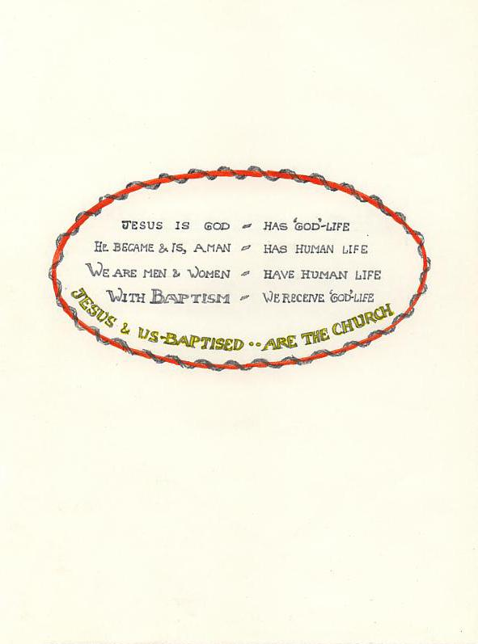

By life sharing with Jesus, man-baptised is brought into the life of
the Father and the Holy Ghost, for they and Jesus are one.

Three distinct persons, Father, Son, Holy Ghost, in whose name we
are baptised, are one God, with one mind to know, one will to love,
one nature - God.

The life received in Baptism brings the recipient into union with the
Holy Trinity, who are God. [John 14:7-17]
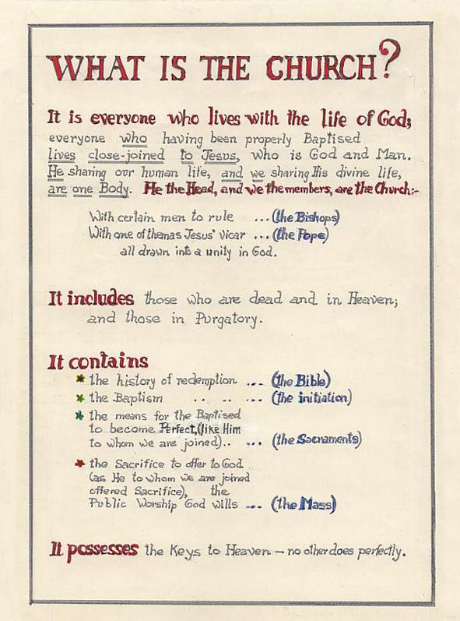

Jesus did very little teaching, in that he wrote nothing down.

How then is it that he is a force in the world today, nearly two thousand years later? How is it that his teaching has suffered no distortion; the governing structure he set up to convey it to future generations is still intact; the Life that is above human life, still dispensed to all who want it?

These endure because He is with the community he formed, His Church, in the abiding presence in it of God the Holy Ghost. “I will not leave you orphans”, He said, “I will ask the Father and He will send you another Advocate, and when He, the Spirit of Truth is come, He will teach you all Truth.”
[John 14:16-18; 16:13]

It should be noted that the Church Christ established is currently in eclipse, by edict of the Second Vatican Council 1962-65. It lives on in the work of Bishops and Priests adhering to doctrine as defined in the Catechism of the Council of Trent 1545-63.

CHRIST’S CHURCH SECURED IN TRUTH, INFALLIBLY, TO THE END OF THE WORLD

Simon Peter’s pre-eminence: The Church Christ came on earth to establish was to encompass all men and last to the end of time. Its whole content must be preserved intact. No one would be called on to believe, or base his life on, falsehood. This unity and permanence of truth is guaranteed by Christ’s appointment of one man to stand in His place, and be Supreme Head and Chief Shepherd of the Church that He would establish.

This man was Simon Son of Jonas, later renamed Peter. Even his first meeting with Christ was notable. Simon’s brother Andrew had been a follower of John the Baptist, then of Jesus, and telling Simon he had found the Messiah, the Christ whom all at the time were expecting, he brought Simon to Jesus. “And Jesus looking upon him said: Thou art Simon son of Jonas. Thou shalt be called Cephas, which is interpreted Peter'."
[John 1:42]

Two years on, near the time of His suffering and death, Christ did rename him “Peter”, the word in Aramaic also signifying ‘Rock’. Answering the query put to His disciples: “Whom do men say the Son of Man is?” Peter spoke, saying “Thou art Christ, the Son of the Living God.” Jesus said: “Thou art blessed, Simon Bar-Jona, because flesh and blood have not revealed this to thee, but my Father who is in heaven, AND I SAY TO YOU:

That thou art Peter and upon this rock I will build my Church. And the gates of Hell shall not prevail against it……….And I will give to thee the keys of the kingdom of heaven……….And whatsoever thou shalt bind upon earth, it shall be bound also in heaven: and whatsoever thou shalt loose on earth, it shall be loosed also in heaven.
[Matt. 16-19]

The significance of the renaming is that Christ will build His Church with Peter as its foundation. If the ‘Gates of Hell’ are not to prevail against it, it will stand indefinitely. Keys are the symbol of supreme authority, and in the legal terminology of the day ‘to bind’ was to prohibit, and ‘to loose’ was to permit.

These words of Christ would convey to his hearers, the disciples: a promise, made to Peter alone, of supreme authority to rule His Church, making laws and judgments as from God, in a lasting society that Jesus would establish, with Peter as its foundation.

🙞

CHRIST’S PROMISE TO PETER of supreme authority in His Church was fulfilled after His Resurrection, in the words: “Feed My lambs, feed My sheep,” that is, feed My whole flock. [John 21:15-17]

The command to "feed My flock" would mean in a pastoral community to provide wholesome food, in this instance of a spiritual nature, truth; also in this unique case the supernatural food, grace. It would mean to care for, guide and protect the flock. It confirmed Peter as the rock of the Church’s foundation, holding the keys to heaven, equipped with the power and authority to govern it.

Further, the command appointed Peter to Christ’s own office of Supreme Shepherd, since the term of the command was to feed My lambs, My sheep – My whole flock; and as ‘flock’ indicates no exceptions, the ramifications of Peter’s primacy extended over even his fellow apostles. Peter was ‘vicar’ of Christ.
🙞

The conferment took place soon after dawn by the Lake of Genesareth in Galilee, on one of the appearances Christ made during the forty-day period He spent on earth after His Resurrection. He had prepared a meal for them, Peter and six disciples, acting as host. The disciples had joined Peter in his ship for the previous night’s fishing, but they had caught nothing. In the morning at Christ’s request, they tried once more, with an astonishingly abundant result, a miracle.

At the meal’s conclusion, Christ questioned Peter as to his love for Him alone, and on Peter’s fervent three-fold assurance, appointed him to supreme command, there on the shore, it having been made clear that Peter would guard and love the flock as he loved the Shepherd.

🙞

The appointment was made in the context of ships, the sea and a miracle: ‘ship’ as a symbol of the Church, safe haven in the sea of life; a ship moreover from which Christ teaches, as He did literally on the Lake of Genesareth once before, when the crowds pressed upon Him in their numbers. Of two ships, it was Peter’s from which He then chose to teach. [Luke 5:1-3]

At this earlier time also, from the ship drawn out into the deep, a miraculous draught of fish had been made, and Christ addressing Peter had said “Henceforth thou shalt catch men.” The gospel account continues: “And having brought their ships to land, leaving all things they followed Him.” [Luke 5:11]

Before promising him the primacy, Christ had required that Peter put on record his belief in Jesus as Messiah and Son of God. Now, before fulfilling the promise, He required that Peter confirm his commitment to Christ above all others. It was on these terms of faith and love that Peter received the appointment of supreme teacher and ruler of Christ’s Church.

THE FRAMEWORK ON WHICH CHRIST BUILT HIS CHURCH
"He made that twelve should be with Him, that He might send them out to preach." [Mark 3:14]

That Twelve was the number He chose to govern His Church symbolized transmission of government, from that of the Old Testament, i.e. by leaders of the Twelve Tribes of Israel, now superseded, to that of the New Testament. The number remaining after the defection of Judas was returned immediately to Twelve by the election of Matthias and never again changed.

The men chosen to carry out His Father’s will, man’s salvation, were all necessarily given the unique power to frame laws compatible with implementing His message, laws ‘bound in heaven’. Peter was given the power first, separately. [Matt 16:19] The other Apostles received it later, in exactly the same words, as a group with him, [Matt 18:18] but their power, to bind in heaven the laws they made on earth, would not need to be transmitted to their successors, as were the four powers of Office given to Peter alone. These four powers were to extend to future generations, to the end of the world:
Shepherd – Vicar of Christ
Foundation of the Church
Holder of the Keys to heaven
Maker of laws binding in conscience.

Legal and governing powers translating Christ’s truth infallibly into practice were essential to each Apostle individually in those times, when intercommunication would be difficult and often impossible; but once communities were established, Christian truth would be preserved by their successors, united with their head.
🙞

The final command to go to the world and preach His message was given Peter and the other ten Apostles on a mountain in Galilee a short time before Christ ascended to heaven:

“ALL AUTHORITY IS GIVEN ME IN HEAVEN AND IN EARTH: GOING THEREFORE, TEACH YE ALL NATIONS, baptising them in the name of the Father and of the Son and of the Holy Ghost, teaching them to observe all things whatsoever that I have commanded you, and behold, I am with you all days even to the consummation of the world.”

🙞

THE BIRTH OF THE CHURCH: “Await in Jerusalem the coming of the Holy Ghost,” he had told them just before ascending to heaven. “He will teach you all things, and bring all things to your mind, whatsoever I have said to you.” [John 14:26 Luke 24:49]
Ten days later, that is the fiftieth day since Christ’s Resurrection, when the Apostles were gathered together, a sound was heard like a mighty wind approaching. It came and filled the whole house, and suddenly, parted tongues as if of fire appeared over the head of each Apostle, “and they were all filled with the Holy Ghost.” [Acts 2:4]

This was Pentecost, the Birth of the Christian Church, and going out to preach Christ’s message to the diverse multitude of nations in Jerusalem at the time, all were heard and understood as if speaking in each hearer’s own language.

Last and Only
A.D. 33 THE CHRISTIAN CHURCH, now fully set up and launched, is the last and only movement towards mankind for its salvation that God the Creator will ever send. This is clear from Christ’s numerous ultimata on the subject:

“Everyone that is of the truth hears my voice.” [John 18:37]
“He that believes not shall be condemned.” [Mark 16:16] et al.

Man, ‘Image of God’, with intelligence and will power, is obligated to act on words he cannot have helped but hear in his lifetime, words directed to all men for all time, that are designed to lead each man on to a state of increasing likeness to Christ and to the glorious eternity to which these words invite him.
Obligation
Israel
first
Christ directed the Apostles to take his message to ‘the lost sheep of Israel’ first, not first to the Gentiles. [Matt 10:5-6] Spectacular miracles over disease, even death, accompanied their preaching, as if to compel belief: He who rejects you, rejects Me and Him who sent Me.” [Luke 10:16]

Christ’s was a visible Church, an organised society. It had a public rite of entry, Baptism; a public form of worship, the Eucharist. It was governed by the Apostles themselves initially. They made laws and applied sanctions. They appointed successors to themselves. They replaced Judas with Matthias, so that there were once more, visibly, twelve Apostles.
Visible
Society

The other Apostles accepted Peter’s authority. He is given first place in all lists of the Apostles. His was the first sermon, the first miracle, the first reception of converts to Christianity, both Jewish and Gentile. He had settled the question of who was to replace Judas, and at the young Church’s first Council in Jerusalem his views were deferred to and followed. Such was the progress they made that a short twentyfour years after Christ’s Ascension the Apostle Paul could write from Corinth to the Christians in Rome that their faith was renowned ‘in the whole world’. [Rom 1:8]
Functioning
as a Visible
Society

A further nine years later, in 66 A.D., the Jews rebelled against Roman rule and in four years were defeated, 70 A.D. Jerusalem was completely destroyed: ‘not a stone remained upon a stone’, as Christ had foretold. [Luke 19:43-4] This destruction was not Roman practice, which tended to preserve conquered cities, particularly the temples, but the destruction of Solomon’s Temple in Jerusalem signalled literally the end of Old Testament worship, now replaced by the New, the Sacrifice of the Cross of Christ.
Old Testament
Finished,
Replaced

🙞

Why did the Jews reject and crucify their long awaited Messiah, though hope was intense, the time was right, the person of Jesus fulfilled minutely the messianic prophecies, and He himself stated in answer to direct questioning by the Jewish hierarchy that He was the Christ, the Son of God?
Four reasons are proposed: 1. Widespread decadence in the Jewish nation made them unreceptive to a regenerative message. The historian Flavius Josephus, A.D.37-98, in History of the Jewish War writes that at the time of Christ the nation had become morally corrupt to the point of meriting ‘the lightning of Sodom, flood or earthquake’. 2. Jewish national pride, already hurt as a conquered people, resented that the salvation Christ preached was to be universal: the hated Gentiles would be admitted to their own status as Chosen People. 3. Jewish religious leaders disliked His denunciation of their arrogance and hypocrisy and envied His popularity. 4. Above all they had come to see the Messias as a King, who would break the Roman dominion and lead the Jewish Nation to world empire.
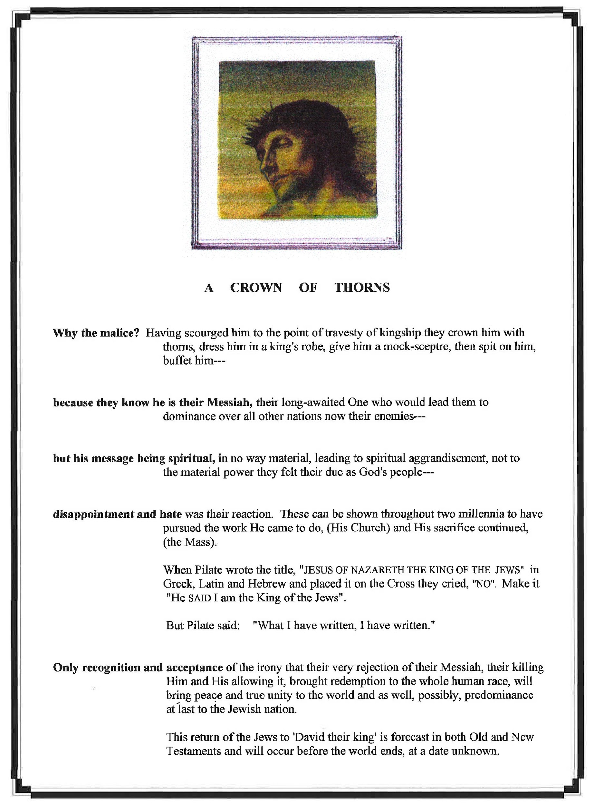

Christianity - part three

Christianity part three - sacrifice

"We are by Baptism, the house of God. The house of God is a place of prayer and sacrifice." V. Many, Marvels of Grace, Chapter III.

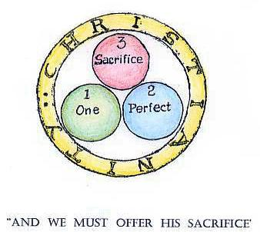

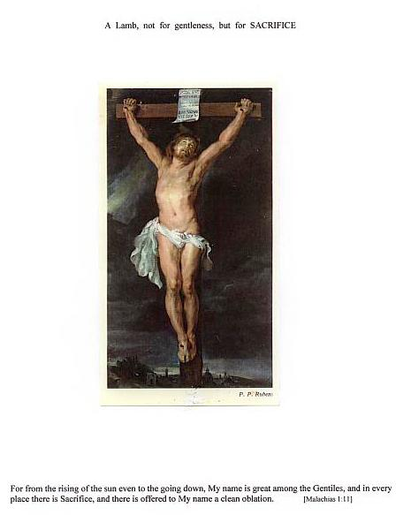

✠ ✠ ✠

The Cross - A Sacrifice

THE DEATH of Jesus was a sacrifice. Though it happened in the natural course of events, it was in accordance with His Will that his blood flowed out on Calvary; and Christian people, united to him as closely as its branches are to the vine, must also be involved in sacrifice, Christ’s sacrifice. This must always be a distinguishing mark of the body that calls itself Christian.

When the armed crowd came for him on the eve of Friday, He could have resisted capture, evaded the soldiers, vanished. He had disappeared on a previous occasion, when they came to take him by force and make him king. But he submitted to the religious rulers, to whom it had become clear he was winning people to him to a degree they considered alarming and dangerous to their supremacy and that of the Old Law, and allowed himself to be led away to his death. His death, being His Father’s will, and his own, and permitted for their purpose, was therefore his sacrifice. Outstandingly, it was a manner of death that would allow participation to the real transgressor, man; not in its redemptive aspect but in that of salvation.

“The Son of man is come, to save that which was lost; the Son of man is come to give his life, a redemption for many.” [Matt 18:11, 20:28] “I come to do the will of Him who sent me.”

His was the sacrifice to which all the sacrifices of the Old Law pointed. He was the Lamb of God, whose blood poured out would save the people of God from eternal death, as the blood of the first Paschal lamb in older times saved from death the eldest son in each Jewish family.

✠ ✠ ✠

SACRIFICE IN GENERAL

All sacrifices in the proper use of the term require that a person officially appointed to sacrifice (a priest), at a place specially designated and set aside for sacrifice (an altar), take a gift intended as a sacrifice, offer it to the Deity for the reason of the sacrifice, and utterly destroy the gift's life or its function.

It signifies a gift given completely to the one who is worshipped, to convey the purpose of the action, whether it is to praise, or ask mercy or implore aid.

All sacrifices, pagan or Jewish, fulfilled these requirements.

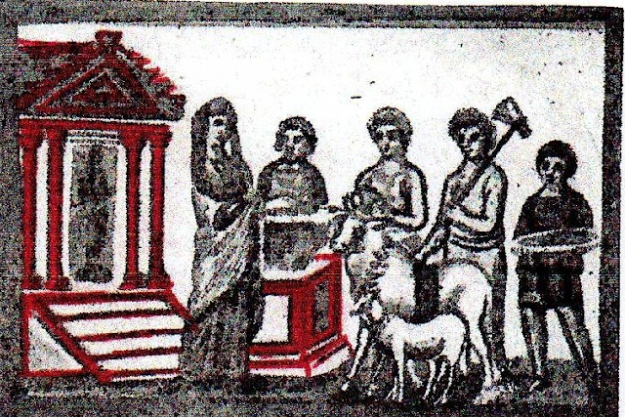

The pagans shown above, ca. 850 B.C., were about to offer sacrifice to the 'god' in the temple, and illustrate sacrificial procedure.

The temple servants would kill the animals, the blood would be collected, and the priest would pour out the blood on the altar, for the life blood signified the essential life and usefulness of the offering, which they meant to transfer to the deity, renouncing irrevocably their own use of the gift, this for the purpose it was hoped to achieve.

To sacrifice is instinct in the human heart: all men of all races at all times have offered sacrifice; but only the Jewish people offered sacrifices to the one living God. One tribe, that of Levi, were the official offerers of sacrifice at the altar in the Temple of God in Jerusalem.

In sacrifices where they consumed what they offered, the intention was to identify themselves with the meaning and the object of the whole action.

Their sacrifices were powerless in themselves to achieve the expiation they longed for, but had the value of sincere worship of God and of being a sign of the Sacrifice to come.

Illustration from the Vatican MS Vergil, 4th Century A.D., Gould & Whiteley, Vergil’s Aeneid, Bk.4, London, 1965, p.3.

THE CROSS - A SACRIFICE

The killing of Christ by the soldiers was not Christ’s act of sacrifice. The act of sacrifice of Christ was his permitting his own life blood slowly to drain away from him, till it was all gone and with it His life; this for the intention to expiate the sins of men. He as Mankind, was making total reparation for the sin of Adam and of all sin.

The wood of the Cross was not the altar. The body of Christ himself was the altar upon which his life blood ran out for the saving of the world.

He was the priest of the sacrifice, controlling the action. He gave assent that his life be given up, that He himself fulfil the function of Victim. He embodied its purpose, as Himself Union of God and man, because the end for which his sacrifice was offered was union of man with God.

After three hours, Christ’s voice rose up in a final cry as He died: “It is consummated.” It was at this moment that his sacrifice was effected. It was in that moment that man’s debt to God was paid.

This sacrifice of Christ’s on the Cross was the one, absolute and universal redemptive sacrifice.

🙞

Christ’s actions before his death and after his resurrection show that his sacrifice would be efficacious.

His purpose to draw mankind to God again, to let it share God’s life again, he set up during his public ministry the ways and channels by which the Gift of Life he would win for mankind would be conveyed to them, (the sacraments) and he inaugurated a body to continue his work of redemption and sanctification, (the Church).

By this, and because success was inherent in his being sent, and by his resurrection, Christ
showed that his act of loving redemption would be accepted, would achieve its purpose.

As long as the world shall last, Christ is still the Victim and the Priest of sacrifice, interceding always for man before God the Father in Heaven.

THE LAST SUPPER - A SACRIFICE

Christ offered a sacrifice, before he offered the sacrifice of the Cross. This was at the Last Supper in Jerusalem, on the eve of his death. His conversion, during that last Pasch Supper, of wine into his blood as well as bread into his body, was a sacrifice.

If he had meant to institute a sacrament only, and so allow us to unite ourselves with Him, then the consecration of bread alone into his Body would have achieved this end. There would have been no point in consecrating wine into his Blood separately, since the term ‘body’ ordinarily assumes and includes the presence of its blood.

And that is what Christ meant to convey, at that final meal, when he made his living Body and its Blood present, but as if separate, the function departed.

Christ at the supper table with the eleven disciples who now remained, said:
"I have longed so much to celebrate this Pasch with you…
take and eat, THIS IS MY BODY
take ye and drink, THIS IS THE CHALICE OF MY BLOOD, of the New and Eternal Covenant, the Mystery of Faith,
which shall be shed for you and for many for the remission of sins.

These, His words of consecration, say: “This is ME, as dead and offered for you.” This is a true sacrifice. It has the Priest … Christ
the Victim ... Christ Himself
the Destruction ... Body and Blood shown as separated.
the Purpose ... The remission of sins.

🙞

This is the deeper aspect of the Holy Eucharist, Sacrament, to which reference was made on page 49, and it is known as the Holy Eucharist – Sacrifice.

It is clear that Christ’s consecration change of the substance of bread and wine to that of his Body and Blood has two intrinsic features, Sacrament and Sacrifice, and the latter is pre-eminent in the central truths of the Christian Faith.

The nature of his living presence hidden beneath the appearance of bread and wine at the Last Supper, was himself as he was then, Jesus of Nazareth, God and man. He wished to demonstrate also that he was there as a victim offered in sacrifice to God for us, for the expiation of the sins of the human race.

NEW TESTAMENT PASCH FORESHADOWED

Integral elements used by God Incarnate, the day before His death, to institute the renewed Paschal Supper-Sacrifice, go back to the dawn of history. Adam's first two sons, Cain the farmer and Abel the shepherd offered to God the fruits of their respective day's labour: Cain the products of the earth, Abel a lamb. Abel's sacrifice was pleasing to God; Cain's was not, and Cain, angry, killed him. Abel, a shepherd, innocent, unjustly slain, his offering a lamb, is taken as a figure of Christ, himself "the Lamb of God". Cain for his crime was marked and made a wanderer until he settled "at the east side of Eden". Expelled from his people, Cain could be seen to parallel Man expelled from paradise. [Gen.4]

The term "Israelite" arises from Noah's son Israel, who was advised in a dream to live in Egypt, where his descendants remained for four hundred years. They became numerous and powerful to the extent of being seen by the Pharaoh as a threat to his sovereignty. He commanded that they be harassed and made to live and work as slaves. Their plea to be released and allowed to leave Egypt was rejected, but plague after plague inflicted by God on the Egyptians brought his consent, only after their first-born child and beast were killed. Those of the Israelites, who instructed by God through Moses, had daubed their door posts with the blood of the lamb sacrificed in their Pasch Festival that night, were spared. Pharaoh in fear and horror let them go, and the Israelites set out into the desert en route for the land promised them by God. Their parlous state in Egypt from which release was longed for was like the state of man, now born lacking the sanctifying gift that brings Heaven within his reach. [Exodus 3:8]

The meal eaten on the eve of departure from Egypt saw the combining of the ancient grain and lamb offerings. By command of God through Moses it was to be celebrated in this combined way, "with an everlasting observance". [Exod.12:14] The bread was to be unleavened, because of the time factor for leavening, the Egyptians were pressing them to go, and because it was important that the association with delivery from slavery be retained. Only unleavened bread was to be used, and for seven days, giving importance to the two aspects of the one festival, bread or Azymes and Pasch or Passover.

Once arrived in the promised land, God's commands regarding the festival sacrifice were observed minutely. It was offered once a year, in Spring, because that month saw their release; it was celebrated "only in the place the Lord thy God shall give thee, that his name may dwell there." This was the Temple in Jerusalem, Solomon's magnificent Temple by the time of Christ, and celebrated at sunset because that was the time of their departure of old. It was a seven day Festival and combined the two offerings, Azymes, or bread, and the lamb, and was known as the Pasch or Passover. It foreshadowed the Christian Holy Week. [Deut 16]

Fourteen centuries had passed between that final meal in Egypt and its celebration on the eve of His death by Christ and his Apostles. He followed meticulously the old form, then introduced the reality, the sacrifice of the New Law, of which until now it had been only the shadow. The Last Supper is the point where Old Testament metamorphoses into New Testament, given fulfilment the following day, Friday, a day on which God made Man and Christ on the Cross said: "It is consummated."

THIS THEN WAS THE PASCH SUPPER that Jesus presided over with his disciples for the last time: a feast and communion in sacrifice arising from the earliest history of God’s people; a memorial of their deliverance from slavery and a thanksgiving for their possession of the Promised Land. In the Pasch they knew themselves blessed by a temporal deliverance; in it they looked forward to a spiritual expiation through One who was to come.

The Pasch observance combined a clean offering, bread, with one in blood, a lamb, and in celebrating it they were obeying God, whose direct command it was, to celebrate the Pasch, perpetually. [Exodus 12, Numbers 9:1-14]

The food around which the strict ritual of the meal proceeded was the Paschal Lamb brought back from the Temple and roasted whole; red wine mixed with a little water; bitter herbs; cakes of unleavened bread; and a sweetening sauce called haroset, a mixture of fruit, vinegar and honey.
🙞

The Last Pasch of the Old Testament, First of the New
1. THE PASCH SUPPER OPENS with a blessing of the feast. The father of the family, or head of the group, blesses God for giving this feast to his people. The first cup of red wine is blessed and drunk.
2. Then come the bitter herbs and the unleavened bread. The herbs, reminiscent of those they ate in their harsh desert migration, are to be dipped in the bowl of sauce. (Jesus takes a small piece of bread, dips it in the sauce and hands it to Judas. It is a customary courtesy from host to favoured guest in Eastern lands, and Jesus makes of it a sign to the disciple who asked, that it is Judas who plans to lead enemies to a place where they can take Him prisoner without the knowledge of the crowds. Judas takes the morsel, and departs.)
3. The Paschal Lamb is served, the host explaining the ancient symbolism of the meal. The first part of Hallel, Song of Praise, is sung.
4. Passing of the second cup of wine concludes this part of the meal.

5. A blessing is said as the unleavened bread is broken. The voice of Jesus breaks the silence that traditionally follows, with the words: “Take and eat, this is my body delivered for you.”
6. Next the Pasch lamb is eaten.
7. The third cup of wine is drunk, with a thanksgiving to God for the meal.

8. The final cup of wine, the ‘cup of benediction’ is given its blessing. Here again the voice of Jesus enters, breaking the tradition of the years with the words: “Drink ye all of this. For this is my blood of the new testament which shall be shed for many unto remission of sins. Do this, for a commemoration of me.” They drink. The second part of the Song of Praise follows, and they depart. [Matt 26:26-8, Luke 22:19]

Mgr F.X. Poelzl, STD,”The Passion and the Glory of Christ”, trans. A.M.Buchanan M.A.London Revised & ed. C.C.Martindale SJ, Section II The Paschal Feast and the Last Supper, pp.23-60.

HOW THE APOSTLES TOOK IT .. A.D. 33

The words that Jesus introduced into the ritual of that last Paschal meal “my body, given for you…my blood, shed for you" were traditional language of sacrifice, in particular sacrifice of expiation, well understood by the Apostles, as Jews brought up with this an ever present and important factor in their lives.

Their whole history was full of the story of sacrifice, from the patriarch Abraham’s sacrifice of a ram in substitution for his young son Isaac, to Melchisadech the high priest, who offered to God bread and wine.

His words at the supper said plainly to them ‘Sacrifice’, in fact, ‘Myself, sacrificed in expiation’, and they saw the next day its relation to the Cross: not two offerings but one.

After His Ascension, whenever they followed out his command to them to ‘Do This’, they saw it fulfilling the ancient prophecy of Malachias 400 years earlier, when unworthy sacrifices of maimed animals and spoilt produce were being offered to God by the Jews.

“I have no pleasure in you, says the Lord of Hosts, and I will not accept a gift of your hand.
For from the rising of the sun to the going down, my name is great among the Gentiles: and in every place there is sacrifice; and there is offered to my name a clean oblation. For my name is great among the Gentiles, says the Lord of Hosts." [Malachias1:10-11]

God’s rejection of sacrifices current in the Old Law is seen in this prophecy, as well as the acceptability to Him of a sacrifice that was to come, now made real and permanent at this last Paschal meal, Christ's final gift, that we too might offer the expiatory sacrifice as the first duty and highest privilege of our lives.

NEW TESTAMENT ESTABLISHED
The Passion and death of Christ could be said to have begun in Bethany, a town less than two miles from Jerusalem, in the last week of His life.

Earlier, walking in winter in the Temple, in Solomon's porch, Jews had come around him saying: "How long will you hold us in suspense? If you are the Christ, tell us plainly." Christ replied that they believed neither his words nor his works; they were not his sheep, who do believe him and to whom he gives everlasting life. He added: "I and the Father are one," and they picked up stones to throw at him. When He asked for which of his works did they stone him, they said "we stone you for blasphemy," and tried to arrest him. He escaped their hands and went beyond the Jordan to where John had begun his baptising. [John 10: 22-40]

It was probably while there that he received news from Martha and Mary that their brother Lazarus was sick and would He come. He delayed two days before leaving for Bethany, arriving when Lazarus was already dead and four days in his grave. Conducted to the gravesite by the two sisters and many mourners, He with some ceremony and a prayer to His Father, called Lazarus from the grave. They all saw Lazarus rise from the tomb, still in his winding bands, from which they loosed him, and many were converted. But some went to the Pharisees and told them what Jesus had done. [John 11:1-46]

This was the catalyst. The chief priests and Pharisees held a council to decide what to do. They were already agreed that Jesus must die, but a way to achieve it had yet to be found. Only the Roman Governor, not they, had the power of life and death. They gave a commandment that if anyone knew where Jesus was, they wanted to be informed, so that they could apprehend him. And so it remained until Judas showed them a way.
[John 11:47-56]

The opportunity came six days before the Pasch, when Jesus came again to Bethany where Lazarus lived his resurrected life. Jesus was greeted with joy, and a supper arranged for him at the home of Simon, known as Simon 'the leper', but obviously cured, probably by Jesus. Lazarus was at table with Him, and the disciples, or some of them, including Judas, the keeper of the purse. Martha served.
[John 12: 1-2, 11:18]

During the meal, her sister Mary took a phial of costly oil, Spikenard, and breaking the sealed neck of it, poured it over the head and feet of Christ, anointing them. The fragrance filled the house, but Judas protested at the waste. Putting the value of the oil at 300 pence, he said the money could have been given to the poor. In so doing he revealed his cupidity rather than his love for the poor, according to evangelist John's account. [John: 12:3-6, Matt.26:6-13, Mark 14:3-9]

But Jesus commended Mary's action. "She has done it for my burial, and it will be told of her wherever this gospel shall be preached in the whole world. The poor you have always with you, but not Me. The incident reveals the universality of His message, His immanent death, and the character of Judas.
[John 12: 7, Matt. 26:13 , Mark 14: 9]

The next day, a Sunday, Jesus prepared to go to Jerusalem to observe the Pasch.

-2-

Great crowds had poured into Bethany, not only to see Him but also to see the walking miracle of Lazarus, whom the chief priests thought to kill as well as Christ. He was the reason greater numbers of Jews were leaving them and following Christ. When the crowds observed that Jesus had commenced the short journey to Jerusalem, they cut palm branches to strew in the way and cried "Hail, King of the Jews", as mounted on "the colt of an ass", in fulfilment of a prophecy concerning the King of Israel, he made a solemn triumphant entry into Jerusalem, met by the crowds who were already there for the Pasch.
[John:12:10-12, Zach. 9:9]

It was the very day on which the law required Jews to set aside the Paschal Lamb. His choosing that day indicates that the time had come for the true Victim to take the place of the figure. The high priests, alarmed, said "We prevail nothing; the whole world is gone after him."
[Exodus 12:3, John 12:19]

Opportunely for them, Judas, having decided on betrayal of his Master, came and asked them what it was worth to deliver Jesus into their hands. They said "Thirty pieces of silver". They discussed how it might be done without arousing the people, and a midnight arrest in a secret place was arranged, for the evening of the day of the Pasch.
[John 13:2, Matt.26:14-16, Luke 22:3-4, 6]

✠ ✠ ✠

It was night when Jesus was apprehended. Leaving the supper room with his disciples, he went over the brook Cedron to the special place on the Mount of Olives that Judas knew, because He often went there with them.

Judas came with soldiers, armed temple servants and torches to apprehend him. All through the night they interrogated him, before two different Jewish authorities and finally by the morning hours of Friday, before Pilate the Roman, in whose courtyard they scourged him and crowned him king in derision before making him carry his cross to the place of execution; where he arrived around noon, was nailed to it; it was elevated and he died about 3 p.m.

They had him down from the cross and entombed in a nearby garden sepulchre before that one day, by Jewish reckoning, was over. But the third day thereafter, Sunday, was the Resurrection.

✠ ✠ ✠

OFFICIAL REACTION: THE JEWS’ GUARDS SET TO PREVENT ‘RESURRECTION’ BECAME ITS FIRST WITNESSES. [pp. 17-19]

Members of the Hierarchy came to Pilate, the Roman Governor, after Christ's entombment on Friday, asking him to put a guard on the Sepulchre for three days. They remembered Christ had said "After three days I will rise again" and feared his disciples would steal the body and claim resurrection. But Pilate refused, saying that they had a Guard and could guard it themselves. The Chief Priests and Pharisees did so, making the Sepulchre sure. They sealed the stone closing the entrance, and set their Guards. Matt.27:62-66

Pilate had not wanted to kill one whom he saw as an innocent man, but feared Caesar's displeasure should he not placate the Jews. He did however publicly wash his hands of the whole affair, saying "I am innocent of the blood of this just man.", whereupon the chief priests declared: "His blood be upon us and upon our children." Matt.27:24-25

On Resurrection Sunday at dawn a great earthquake occurred. The stone was rolled back by an angel, revealing an empty tomb. The Guards were "struck with terror and became as dead men". The angel told the women disciples present: "Jesus who was crucified is risen as He said." and showed them where the body had lain. They would see Him in Galilee he said, and the women departed in joy. Matt.28:1-7

Some of the Guards went to the Chief Priests with the news of the empty tomb. The Priests and Ancients conferred, following which "a great sum of money" was given them, with instructions to say that the disciples had come by night and stolen the body. They would be protected should the Roman Governor hear of it. The Guards took the money and did as they were told. They spread the false account that has "gone abroad among the Jews even to this day." Matt. 28:1-15

THE JEWISH HIERARCHY FOREWARNED [See also pp. 69-70] They were forewarned twentyone years earlier, when at the age of twelve years Jesus spent three days discussing the scriptures with the Doctors and Elders in the temple of Solomon. Their religion was one of expectation, its central doctrine belief in a Messiah or Redeemer to come.

All that had been foretold of the Redeemer was fulfilled in Christ in minutest detail. He was of the line of King David; born at Bethlehem of a virgin mother. He was called the Son of God. He was from Nazareth, a Nazarene; he would judge the poor with justice; his empire would be multiplied; his Kingdom would be assailed but would last forever; he would judge all men and crown the just with glory.
Yet he would be a man of sorrows, despised and the lowest of men; sold for thirty pieces of silver and the silver used to buy a potter’s field. He would be offered of his own will, would not open his mouth; would be led as a sheep to the slaughter, dumb as a lamb before his shearer; his hands and feet pierced, his garments auctioned. He would be a light to the Gentiles and bring salvation to the ends of the earth. The God of Heaven will set up a Kingdom that shall never be destroyed.

Another prophecy was fulfilled from the Cross itself: “They shall not break a bone of Him.” The legs of the two thieves were broken, to bring quick death by asphyxiation, but not those of Christ, He was already dead. John 19:33-36

YET THE REACTION OF THE JEWISH HIERARCHY WAS REJECTION. Accounts of the three years of His public life are replete with proof of their implacable hostility, in the face of His stupendous miracles, to the person, claims and message of Christ.

When the dumb man is cured, the Pharisees say it was done by the power of the devil. When He says: "Before Abraham was, I am" they take up stones to throw at him. After the parable of the vineyard, knowing its application to them, they "would have taken him prisoner, but they feared the crowd." Matt. 21:46
They loved their position of power, and saw their own demise, with possible Roman domination of all Palestine, in the joyful enthusiasm of their people for the person, the teaching and miracles of Christ. They began to seek grounds for a death sentence, which only the Roman Governor, not they, could grant. Caiphas, High Priest of the year, pronounced as expedient, "that one man should die rather than the whole nation perish." John 11:46-53

In assembly with all the priests, scribes and ancients, he formally asks Jesus, arraigned before him: “Are you the Christ, the Son of the blessed God?” Jesus replies: “I am. And you shall see the Son of man sitting on the right hand of the power of God and coming with the clouds of Heaven.” This is taken to constitute blasphemy, guilty of death.
Mark 14:61-64

Their taunting as He hung on the Cross: “Let Christ the King of Israel come down now from the Cross that we may see and believe” was short lived, lasting only until they had to bribe their guards to silence following the Resurrection. They gloated at Calvary that Christ their enemy was dead, unaware that they would find the veil of the Temple was torn in two from top to bottom, symbolically ending the Old Testament. Mark 15:38
🙞

WHAT, under its Hierarchy, ISRAEL CHOSE BY REJECTION OF A SUPER-NATURAL MESSIAS: On Mt. Sinai, in the third month of the first year of their forty year wandering in the desert, God through Moses had said: “The children of Israel shall be my elect above all people; shall be to me a priestly kingdom, a holy nation if they hear my voice and keep my law.” The children of Israel through their leaders had answered” “All that the Lord has spoken we will do.” Exod. 19:5-8

By the time of Christ the standard of their conformity to that Law had fallen in all but appearances. “They did not listen when Christ spoke to them of the reality of a higher life; a higher unity for the people of the world than that of their national life”– in fact a divine life, in eternity, in spiritual union with Christ. The Messianic idea with which they were imbued had come to embrace the Nation as a whole pursuing the dominance seen as their due over the rest of mankind. This would be furthered by conquest, but above all by financial control.

But the Jewish Nation is still the only one ever chosen and consecrated to the service of God; its crime of deicide brought salvation to the Gentiles. The children of Israel may one day be the means by which the Gentiles in defection return to God. Deut 4:30 et al.

CHANGE OF AUTHORITY:
OLD TESTAMENT TO NEW - JUDAISM TO CHRISTIANITY

- Judaism was a religion of expectancy of a Messiah.

- Christ was born and fulfilled all the Messianic prophecies.

- Christ appointed twelve Apostles to head the Régime He was establishing – a clear replacement of the existing government of twelve leaders of the twelve Tribes of Israel.
- When on Calvary the taunt was levelled: “Come down now from the Cross and we will believe you”, Christ their Messiah was in the act of achieving Man’s Redemption – possible only to One who was both God and Man – by His now immanent sacrificial death. There on the Cross He said: “It is consummated”, and died, his death full atonement for Man’s rejection of God, his laws and his promises.

- In the ensuing earthquakes and terror, those of the Hierarchy present on Calvary would find the veil of the Temple of Solomon split from top to bottom, making bare its Holy of Holies.

6 Thirtyseven years after the Crucifixion, 70 A.D., Jerusalem itself was flattened to the ground, “not a stone remaining on a stone”, the Old Law even physically shown as ended.

Christ’s Supranational, essentially Spiritual and Supernatural Order, now established from God as the one and only way for mankind, was rejected by the Judaic Hierarchy in favour of deification of man’s natural powers, to be exercised in a system of Natural World Domination.

✧

Yet it is not to be supposed that Judaism will not, before the world ends, re-assume its vocation of the Chosen of God, and accept its true Messiah, God become Man, Christ the King.
“The children of Israel shall sit many days without king, without prince, without sacrifice, without altar, without ephod and without theraphim. And after this the children of Israel shall return, and shall seek the Lord their God and David their King. In the last days they shall fear the Lord and his goodness.” Osee: 4: 4,5

WHAT HAPPENS AFTER DEATH? [Refer also p.95]

Aquinas: "Without the senses, the soul will know only itself and God."
Heb.9:27: "It is appointed unto Man once to die, and after this the judgement", the finality of “once” negating the idea of a second chance. His state, for good or ill, in accord with this Judgment, will be his for eternity.

The Soul of each man, woman or child, born or unborn, will undergo a personal judgment immediately after death and will continue to exist in one of four places: Heaven, Limbo, Purgatory, or Hell.

Heaven: If baptised, and free from any fault or stain, the soul of each man, woman or child will find itself in Heaven, in the joy of knowing God, in complete happiness.

Purgatory: If baptised, but in debt still for past sin, the soul will find itself in Purgatory, there to remain until in justice it may enter Heaven and eternal joy. The Baptism can be of water preferably, but also of blood or desire, i.e. the blood of martyrdom, or of desire, for those ignorant of the need for Baptism but who lived according to their conscience. Neither of these however is the Sacrament of Baptism. "They do not imprint on the soul the baptismal character which enables a man to participate in the Priesthood of Christ."

Limbo: The souls of children unborn and faultless but obviously unbaptised, will know a purely natural happiness in a place distinct from Purgatory, Limbo, as will children that die unbaptised before reaching the age of reason; also those equivalent to infants, the congenitally brain damaged.
The souls of the Just who died before Christ's redeeming death awaited deliverance in Limbo, effected by Him during the period between His death and resurrection.

Hell: Those individuals, baptised or unbaptised, who consciously chose not good but evil during their life on earth; who deliberately closed their minds to their inborn knowledge of right and wrong and with all their heart and will rejected God and His goodness, will go to Hell and eternal misery.

This Particular or Individual Judgment will reveal to each, at that moment, its justice.

AFTER THE GENERAL JUDGMENT AT THE END OF THIS WORLD when the earth is renewed, each soul will rejoin its body and continue to live in the state it merited during its time on earth through its use of its intelligence and will, namely, and certainly, in Heaven or Hell. As to Limbo, "the absolute necessity of regeneration, being born again of water and the Holy Ghost, is insisted upon in the New Testament and the means of regeneration are not available after death"; but "we ought to believe that these souls enjoy, and will eternally enjoy, perfect natural happiness."

The General Judgment will reveal to each the wisdom and justice of God's treatment of every member of the human race. It will also reveal the majesty of Christ and the glory of those who die in grace with Him.

SIGNS FOREGOING THE LAST JUDGMENT:
3 principal signs: * The preaching of the Gospel throughout the world
* A departure from the Faith
* Antichrist

A.D. 33 to A.D. 55 .. SACRIFICE OF THE NEW TESTAMENT

The disciples of Jesus present at the paschal supper followed his command ‘Do This’. It is reported as a frequent, almost daily occurrence. They recognised that ‘This’ was not to be understood as the whole Pasch supper, strictly an annual event, and that his command obviously gave them the power to ‘Do This’. [Acts 2:20]

They knew it as a sacrifice from the start. As well as recognising the set language of sacrifice, the Apostles as Semites knew that an agreement is sealed in blood, with a real victim, not just a symbol or sign. Christ said: “This is my blood of the new testament.”
[Matt.26:28]
🙞

“As often as you shall eat this bread and drink this cup, you proclaim the death of the Lord.”

Christ’s command given to the apostles at the Last Supper of the Old Law had been observed for more than twenty years when in 55 or 56 A.D. Paul wrote this, the first account of the Lord’s Supper ever written, in his initial letter to the Christian community in Corinth, Greece.

1 Cor.11:23-29
"Be followers of me, as I am of Christ. For I have received from the Lord that which I handed on to you, that the Lord Jesus, the same night he was betrayed, took bread, and giving thanks, broke and said: 'Take and eat. This is my body which shall be delivered for you. Do this for the Commemoration of me.'

In like manner also the chalice, at the end of the Supper, saying: 'This chalice is the New Agreement in my blood. This do you, as often as you shall drink, for the commemoration of me.' For as often as you shall eat this bread and drink the chalice, you shall show the death of the Lord, until he come.

Therefore, whoever shall eat this bread or drink the chalice of the Lord unworthily, shall be guilty of the body and of the blood of the Lord. But let a man prove himself, and so let him eat of that bread and drink of the chalice, for he that eats and drinks unworthily eats and drinks judgment to himself, not discerning the body of the Lord."

Paul here sets forth for the people of Corinth the reality of sacrifice and the reality of Christ's presence in the liturgical celebration, His command obeyed.

A.D. 55 to A.D. 1970

The 'breaking of bread' practised by the first Christian communities is referred to precisely as Sacrifice in the very early document The Didache or Teaching of the Twelve Apostles c. 96 A.D.

A.D. In The Didache the necessity of reconciliation with one's enemies, mentioned by the
55-135 Apostle Matthew [5:23], is made a pre-requisite to the Eucharistic Sacrifice.

Didache "And on the Lord's own day assemble in common and break bread and offer
Chap.14 thanks; but first confess your sins so that your Sacrifice may be pure.
2. And let not any man that is at variance with his fellow join you until they be
reconciled, that your sacrifice be unspoiled.
3. For this is that which was spoken of by the Lord: In every place and time
there is sacrifice and there is offered to my name a clean offering, for my
name is great among the Gentiles, says the Lord of Hosts."

By the time of Justin, Christian defender martyred ca. A.D.165, many Christians had suffered cruel death for refusing to sacrifice to false gods, and Justin himself wrote, probably about 150 A.D.: Apol.1:66 "By the sacrifices which we Gentiles present to him in every place, that is the bread of the Eucharist, and likewise the chalice of the Eucharist,…we glorify his name."

🙞

A.D. Such was the emphasis on this feature of worship throughout the whole of the Old 135-1968 Testament, that it would be strange if sacrifice were not a strong element of the New
Law, the New Testament.

The Old Pasch sacrifice itself, made spiritually obsolete by Christ's Pasch on the eve of his death, lasted in fact only another 37 years. The city of Jerusalem was destroyed in 70 A.D. by the armies of the Roman General Titus, son of the Emperor Vespasian, and its beautiful Temple of Solomon was burnt to the ground. Old Law sacrifices ceased; were never offered again, and thus gave way literally to Christ's blood covenant of the New Law, the Eucharist, the Mass.

🙞

A.D. So through over 19.5 centuries until today, and onward into the future for as long
1968? as it shall be till there are 'enough' people for the Kingdom of God and Our Lord
shall come again, Christ's command given that night to eleven men of his choosing
has been kept, and Christians, the new People of God, have made of His sacrifice 'a
perpetual observance'.

Note: The sequence was broken A.D.1970 following the Second Vatican Council 1962-65. The duration of and reason for
this anomaly are unknown.

THE NEW TESTAMENT SACRIFICE - TO THE END OF THE WORLD

His ‘Do This’ meant: “Make present, to commemorate me,
that which I have made present.”

In doing what he commanded, whenever they did so, those who were thus given the power, made present Christ himself, shown as sacrificed to God for the expiation of sins.

In speaking the words he used, they did not speak as themselves. They spoke as Jesus himself, “This is my body; this is my blood” and they made present, each time, the sacrifice of Christ in a ‘clean’ manner; and partaking of the Victim, they were one with Him and with his sacrifice.

🙞

Over a thousand years had passed by, from the first Paschal meal in Egypt on the night before God’s people were liberated, to the Paschal meal they celebrated in Jerusalem on the eve of Christ’s death.

It began as it always had in the Old Agreement, a memorial of freedom gained; a thanksgiving for the Promised Land and a sign of the bond of joy between all who were God’s.

It ended as the Celebration of the New Agreement, a new memorial of Jesus’ death, our freedom gained; as a new thanksgiving for our possession of the Promised Land, for heaven begins on earth when we become ‘sons’ of God in baptism; and as a sign of the new bond of joy of all in Christ and each other now and forever.

This New Celebration however is more than a memorial. It is the act of deliverance itself, perpetuated, renewed.

🙞

The first Christians gave only two names to the Celebration: ‘breaking of bread’ and ‘the Lord’s Supper’. Then came the terms the Liturgy, the Sacrifice, the Assembly, the Mysteries, the Mystery of the great action, the Thanksgiving (Eucharist) and finally the Mass.
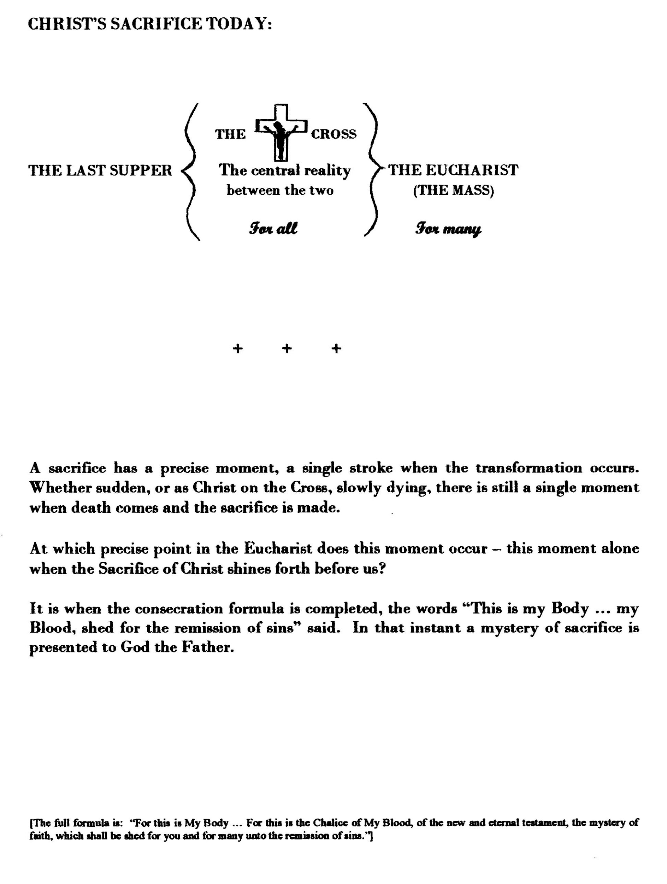

CATHEDRAL wINDOW - PAGEANT OF SACRIFICE

The Eucharist now: Those desirous of understanding the Eucharist (called Mass by ancient custom) may, at a time when the Mass is in progress observe in the great window over the Cathedral altar the whole action - GOD’S DESIGN COMPLETED.

Centrally placed, the initial consecrating of bread and wine is portrayed, in the mind of Christ at that moment his immanent death on the Cross, that sacrificial death that would atone for all sin ever committed, and move God to grant man to become, if he willed, temple of God on earth and heir to heaven.

High above, dominating the scene, is Christ in sacrifice, fulfilling his statement “I, if I be lifted up from the earth, will draw all things to Myself.”

Below at the altar, whenever the Mass is in progress, the pageant is complete: the first Mass in the Supper Room, the redeeming action made on man’s behalf, and man, impotent man, by Christ's command performing that very sacrifice, not now to redeem, but in justice and to save and sanctify.

Note: Sadly the above, written 1969, no longer applies, nullified 13 Oct.1970 by the Second Vatican Council 1962-65 in a ban of unknown duration. Rebuilt 2009, the Cathedral's outline is now hybrid, no longer cruciform.

Cathedral of the Immaculate Conception, St. Mary’s, Perth, Western Australia.

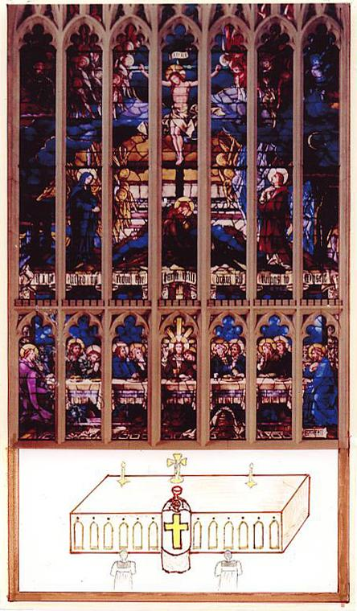

Technicalities of the Eucharist:

The words "shed for you, broken, given for you: link the Pasch Supper with the Cross, whether or not the Supper is itself to be considered a distinct and formal sacrifice. Its purpose is the soul of a sacrifice, and Christ had but one purpose. He has only one self to offer, and only one sacrifice of himself to make, and in the three aspects, the Supper, the Cross and the Mass there is but one sacrifice of Christ.

🙞

Bread and wine, as Melchisadech offered, are not offered to God in the Mass. Christ alone is offered to God in the Mass, as Christ alone was offered to God in the Last Supper.

By the words of consecration, only that becomes present that the words express, namely the ‘body and blood’ of Christ; but with this is included everything inseparable from the body and blood of Christ, the humanity, the soul, the divinity – the whole person of Christ. At the Supper, his work uncompleted, He was present in the Mystery of the Bread and Wine as his appearance showed him to be; later, in the Mass, he is present as Christ in glory, as the whole person of Christ is now.

The celebrant speaks as Christ Himself only in the actual words that change the bread and wine; at other times in the rite, he speaks as himself, a priest.

Only the Consecration itself is sacrifice; the Communion is identifying with sacrifice, and the offering is completed with the completion of the formula, and not when the Victim is consumed.
🙞

Christ is bodily present in the Eucharist in a manner that is outside the range of human knowledge; yet it is a mode that permits of our being ourselves drawn into His sacrifice. The presence of his whole self on many different altars throughout the world simultaneously is also above and outside the natural order.

While on earth after the Resurrection, he on occasion vanished out of their sight, or appeared suddenly in the midst of them, and not long before his death, “transfigured” on the high mountain, his appearance had enraptured his disciples. They saw him ascend finally from the earth until he was obscured from them by the clouds of heaven. Whenever the life of the infinite touches ours there is mystery; but it is mystery, not contradiction.

Christ in the Mass is truly living yet appearing as truly dead; a seeming anomaly. Yet He can and did die but once; by his power he can and does offer Himself afresh that we may join him in penitential character in the action that redeemed us.

-2-

The Christ present in the Mass, is Christ passed through death and ascended to heaven, glorious and immortal, Human, God. This is his state forever. This is the presence that enfolds us in Communion, pledge that we will follow where He led the way. His appearance as the Atonement made, the Will of the Father completed, pleads continually for us before God the Father in Heaven.

We on earth, consuming the Sacrifice, are visible as saved, Christ’s ‘many’ brothers who will know eternity with God and the saints. We wait now only Christ’s return and the final exposition ‘face to face’.
🙞

THE MASS IS BASICALLY, EXACTLY THE SAME ACTION THAT OUR LORD PERFORMED AT THE LAST SUPPER, WITH ADDED NATURAL PRAYERS. It occupies such a fleeting instant, the awesome central action, that time is taken before and after it, the Consecration, to formulate and express intention, awareness of what is happening, the feelings that arise, the duties it evokes.

🙞

This sacrifice arose in the context of Jewish sacrifice. The prayers of the Temple remain and give continuity with the past in the psalms sung, holy scriptures read, in homilies, as a prelude to the Change – the New Law offering. Once, people under instruction were dismissed after these prayers, being not yet of the company of the baptised. A prudent secrecy guarded the holy mystery that follows and is contained in the Offertory, the Consecration, and the Communion.

The People of God offer sacrifice. Only the initiated may partake forever at the Supper of God. For Christ reiterated “unless” you eat…you will not have (eternal) life.” In other words, participation in the Eucharist is obligatory for Salvation.

1 The "discipline of the secret": It was the custom during the first centuries, particularly from the end of the 2nd to the beginning of the 6th, to conceal from the heathen the more sacred rites of Christianity, especially the real nature of the Eucharist. [Sheehan II, p.160.] "Give not that which is holy to dogs. Neither cast ye your pearls before swine: lest perhaps they trample them under their feet: and turning upon you, they tear you."

-3-

IN ALL EARTH’S HISTORY, there is no event comparable to the Mass. It is absolutely unique, even as a religious rite. No other but the Christian Eucharist has been followed so precisely, daily, with such intensity of interest, for close on twenty centuries. Its forerunner the Pasch it has outlasted so far by six hundred years, and this was an annual festival.

It has always been the all-absorbing focus for friend and foe; for the enemies of God, the unceasing point of attack; for Christianity, the well of its life and its central act of worship.

It is our thanksgiving; our reparation; our atonement made; our cry to God to strengthen our one-ness with each other and with Him. We say Eucharist and we mean only sacrifice. Even the Living Presence in the Bread unconsumed, retained for the community’s sick and dying, is inseparably sacrificial. In adoring the Real Presence, we do not forget the Victim offered for our salvation’s sake.

Yet we still see, as the early Christians saw, the ‘death of the Lord’ as always joined to his Resurrection and his Return, and find hope and joy in the Eucharistic celebration.

🙞

THEME: In Baptism begins the mystery of union of man with God; it continues in the sacramental ways; but it expands in fullest measure in union with the redeemer and the redeemer’s sacrifice offered and consumed. Here in the Mass more than anywhere we accumulate for ourselves ‘treasure in heaven’.

A man baptised, must grow in the Life, he must perform the duty he now has, to offer the one sacrifice to God; and in meeting this responsibility he fulfils his own greatest need, for in this he is privileged most to grow to resemble Our Lord, that God may see and love the likeness.

🙞

The sacrifice of Christ exists now. We formally offer it in public on the Lord’s Day and are seen by God the Father as a body with Christ its head in perpetual worship and atonement; in the Communion we are seen as all one in Christ, re-enfolded through Him in the Creator, the Holy Trinity of God.

-4-

WHY WAS THE DEATH OF CHRIST NECESSARY? Two considerations are relevant, though the need, itself undoubtedly existing, is to some extent still a mystery and not fully understood by men.

If a God decides to deify his creatures, so that they may be his companions as it were, and they reject and repudiate the gift and the companionship to join instead with a declared enemy and be self-sufficient, as man did, the ‘deifying’ quality is rightly withdrawn.

Secondly, a wrong committed demands satisfaction and it demands reparation. These being made, the deifying gift may or may not be given again, but satisfaction and reparation are still in justice due. Thus man had lost the deifying gift, and he owed to God satisfaction and reparation, which he was unable to make. Man’s insignificance is unable to make reparation to the majesty of God.

The Old Testament had strong consciousness of the need to atone. There was a ceremonial Day of Atonement, when on the head of an animal all the sins of the race were imposed by voice and hand of a priest, and the animal was driven out into the desert, to bear away forever the sins of the multitude. Thus a poignant longing for forgiveness and re-instatement was expressed.

Christ came. He bore our sins away in infinite satisfaction. God gave again the deifying gift, the sanctifying grace, that we may know him in heaven.

🙞

“I, if I be lifted up from the earth, will draw all things to myself.” [John 12:32]

He was lifted up from the earth by the Cross. In that act he drew men to himself, because the expiation he offered on man’s behalf drew down upon men the holy gift that unites us with the Trinity of God.

But he drew all things to himself, for in man are the constituents of all creation. The elements that compose rocks and stars are in man, the living principle of plants, the sensory character of animals, the intelligence allied to free-will of non-physical beings, angels. In man all nature finds embodiment, he is a compendium of all creation, and in uniting men to Himself Christ made the whole universe one. He drew ‘all things’ to Himself.

“Technicalities" pages 90-93, Apologetics and Catholic Doctrine, Sheehan, M., D.D., Part I, 1947 and Part II, 1950; Kelly, Bernard J., D.D., Part III, 1951, Dublin, M.H. Gill & Son Ltd., Poelzl-Martindale, The Passion and the Glory of Christ, Section II "The Paschal Feast and the Last Supper", pp.23-65, New York, 1919..

6. THE HOLY ORDER - SACRAMENT: "Thou are a priest forever."

SACRIFICE, a work allocated to Christianity alone, necessitates a priesthood set aside for the purpose. In the Old Testament, the sacrifices foreshadowing the Sacrifice of the New, were performed only by priests in the Temple of Solomon at Jerusalem.

After the birth of the Christian Church at Pentecost, Peter, set by Christ at the head of the Apostles, taught and governed with them, administering the Sacraments He had instituted, offering His Sacrifice. Today, and since, Peter's successor and the Apostles' successors teach the same truths, and administer the same sacraments, offer the same Sacrifice, govern as they did.

The natural powers of their office, to teach and govern, together with the powers beyond ordinary human nature that they had received from Christ, namely those to forgive sin and to consecrate the elements of sacrifice, were passed to others by the imposition of hands on the head of the candidate chosen to receive them. This is the essence of the Sacrament named 'HOLY ORDER'.
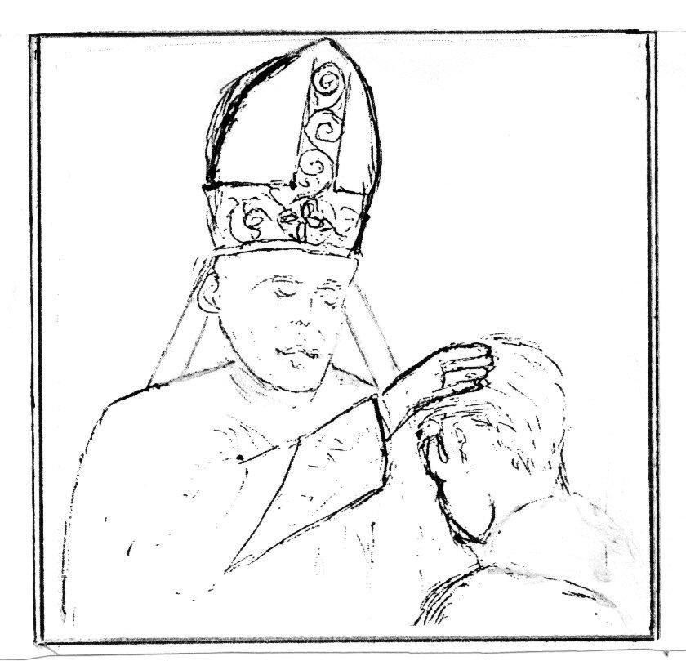

Holy Order is transmitted in its fullness as Bishop, but from the beginning it has been found good to confer the Sacrament in three separate degrees, Deacon, Priest, Bishop. In this way, Holy Order is approached in its full status of Bishop by men trained and prepared.

The Deacon receives, by imposition of the Bishop's hand, the power and jurisdiction to assist worthily at Mass and to preach effectively.
The Priest receives also the power to forgive sin and consecrate the Mass, with jurisdiction to teach, govern and administer the sacraments in a defined section of his Bishop's diocese.
The Bishop receives every sacred and secular power the Apostles received from Christ, with jurisdiction over a large area or country, allocated to him from Rome. His jurisdiction is operative only in union with Rome and could be withdrawn. His non-secular powers would remain.

In the case of the Bishop elected by his fellow Bishops to the bishopric of Rome, all that Peter received from Christ as Christ's vicar is received with the office. He becomes visible head of the church, with primacy not only of honour but of jurisdiction. He receives the authority of his office directly from Christ, the invisible head of the Church. The other Bishops receive their authority, also from Christ, but through the Bishop of Rome who appoints them. Their authority extends only to their own people and diocese; that of the Bishop of Rome, called Pope, extends to the universal church.

-2-

The ‘HOLY ORDER’ is the power of Christ’s priesthood, the power to offer His sacrifice. It embraces a power to forgive sin; His life was offered to remit the effect of sin. It had to be transmissible, as the vehicle He was founding to contain and convey the power of Holy Order was to reach ‘all nations’ to the end of time – a power of sacrifice and of forgiving sin.

The Old Testament had sacrifices of all kinds; the New has but one sacrifice, one Priest, Jesus. From the moment of his conception as a member of the human race He was what He came here to be, the High Priest of the New Testament, offering as both God and man the perfect atonement, His life, for this would achieve the effect desired by God the Father, of bringing humanity back into the bond of life with its creator, eternally in the Vision of God.

By His Priesthood, shared with men by the Holy Order he instituted when He said ‘Do This’, His sacrifice is renewed in the world till it ends.

🙞

PETER GOVERNED FOR ABOUT THIRTYFIVE YEARS. His first bishopric was Antioch; then he moved to Rome, writing his first Epistle there about fifteen years after the Ascension, ca.48 A.D. He wrote his second Epistle there shortly before he was crucified, about twenty years later. History and archaeology prove that Peter did reside and die at Rome. It was his bishopric. There he exercised the full dignity of his Christ-given appointment as infallible head of the Universal Church.

With Peter’s death, the Bishopric of Rome passed by election of the Apostles and Bishops first to Linus, then to Cletus, then to Clement, in quick succession, for to be head of the Christian Church then was to be marked out for death.

There have only been four Bishoprics ever founded by an Apostle, for Constantinople, called Apostolic, was not founded by an Apostle.

1. Antioch .. founded by Peter, his first bishopric, fell away in heresy about
450 A.D.

2. Alexandria .. founded by the Apostle Mark under Peter’s direction, also fell
away in the same heresy, the Monophysite, ca. A.D. 450.

3. Jerusalem .. Bishopric of James the Less, perished with the destruction of
Jerusalem in 70 A.D.

4. ROME .. BISHOPRIC OF PETER, ENDURES, its succession unbroken.

THE SACRAMENT, HOLY ORDER, has a visible sign and form of words. An existing Bishop extends his hands, meaning wholeheartedly to transmit, and the recipient wholeheartedly to receive, the power of Bishop, Priest or Deacon as defined by the Church, and prays in the form appropriate to each.

THE RITE TRANSMITTED:

DEACON: The Bishop, both hands extended towards the candidate, prays that God may bestow on him the gift of the Holy Ghost for the worthy discharge of his duties. This is the essence of the rite conferring Holy Order as DEACON.

PRIEST: The Bishop lays both hands on the candidate’s head, then says: "Hear us O Lord our God, and pour forth on this Thy servant the blessing of the Holy Spirit AND THE POWER OF PRIESTLY GRACE." This is the essence of the rite conferring Holy Order as PRIEST. Other ceremonies follow and are obligatory, but are not of its essence: the Bishop vests the newly ordained Priest in stole and chasuble, anoints his hands with the Oil of Catechumens and presents him with a chalice (of wine and a little water) and a paten (with a wafer) saying:

“Receive the power to offer sacrifice to God and to celebrate Mass both for the living and for the dead."

The new Priest, now a Priest forever of the order of Melchisadech, immediately celebrates his first Mass conjointly with the Bishop, and towards the end the Bishop imposes hands again, saying: “Receive the Holy Ghost: whose sins you shall forgive, they are forgiven and whose sins you shall retain they are retained." The second imposition of hands is appropriate, since Christ instituted the Sacrament of forgiving sins separately from his instituting the Mass, and after his Resurrection.

BISHOP: The conferring Bishop lays both hands on the head of the candidate, who for valid reception of his new powers must be already a priest, then prays:

“Benignly receive our supplications, O Lord, and over this Thy servant pour forth in its fullness the grace of the Priesthood and the might of Thy blessing."

This is the essence of the rite transmitting Holy Order as BISHOP. Other ceremonies follow and are of great significance, but are not of its essence – two other Bishops take part in an important but limited degree, and the new Bishop is anointed with Chrism on head and hands, and is given the pastoral staff, ring, mitre and book of the Gospels.

🙞

The sacramental character thus passed to Deacon, Priest or Bishop is indelible. It cannot be repeated or extinguished; a return to the lay state is therefore impossible. It also gives the power needed in the exercise of the particular degree of Holy Order received. With official, lawful appointment to office, each becomes involved in the work of sanctification that the Apostles were commanded to take to the world, and the world is thereby bound to listen.

HOLY ORDER is the source of the Sanctifying Grace won by the Cross that all men need added to their human nature if the reason for their individual existence is to be brought to reality in the vast unending world of Heaven. Nothing could be more important than to acquire Sanctifying Grace. It is the treasure in the field, to possess which a man would sell all he has. It is the wedding garment without which no one gains admittance to the eternal feast.

Possessing Sanctifying Grace now, in this life, does not bring with it the immediate vision of God or the happiness ‘pressed down and flowing over’ that we will know. That comes only when departing this life ‘in grace and fit to reach Heaven’ our intellect is accorded what is known as the Light of Glory, or Lumen Gloriae, empowering the soul to know God as He is. “Now we see in a mirror, obscurely, but then face to face.” [1 Cor.13:12]

🙞

WHAT THEN IS MAN?

1. Man was created to know, love and serve God and so merit Heaven. Through the first man’s defection, death is the gate through which he must pass to the eternity he himself has chosen during his life. [“It is appointed unto Man once to die, and after this the judgement.” Heb.9:27]

2. The man who dies in the state called ‘just’, that is, possessing Sanctifying Grace, and is free from any debt to God’s justice from past sin, is at once admitted to the Blessed Vision and love of God. [Benedict XI I, #530 (A.D.1336)]

3. The ‘just’ man who yet owes something for past sins, offences or negligences is made fit for Heaven in a state called Purgatory. This state can be shortened for him by the prayer of those still on earth. ["It is therefore a holy and wholesome thought to pray for the dead that they may be loosed from sins.” II Machabees 12:46…"But I say unto you that every idle word that men speak, they shall render an account for it in the day of judgment." (Christ to the Pharisees, Matt.12:36.)]

4. The man dying in mortal sin will not gain Heaven, and like the fallen angels will suffer neverendingly. [If the tree fall to the south or the north, in what place soever it shall fall, there shall it be." Eccl.11:3]

5. Christ came once as a Redeemer, to re-open Heaven to man, fulfilling the eternal purpose. He will come again, on the last day of the world, in power and majesty, as Judge. No one knows when this will be, as the only indication of the world’s duration is “until there are ‘sufficient’ people for Heaven.” Some will hear “Come, possess the Kingdom.” and others, “Depart, accursed.”

THIS IS THE SOLEMN TEACHING OF THE CHURCH.

From the ancient painting reputedly by Saint Luke

“Our Lady of Perpetual Help”

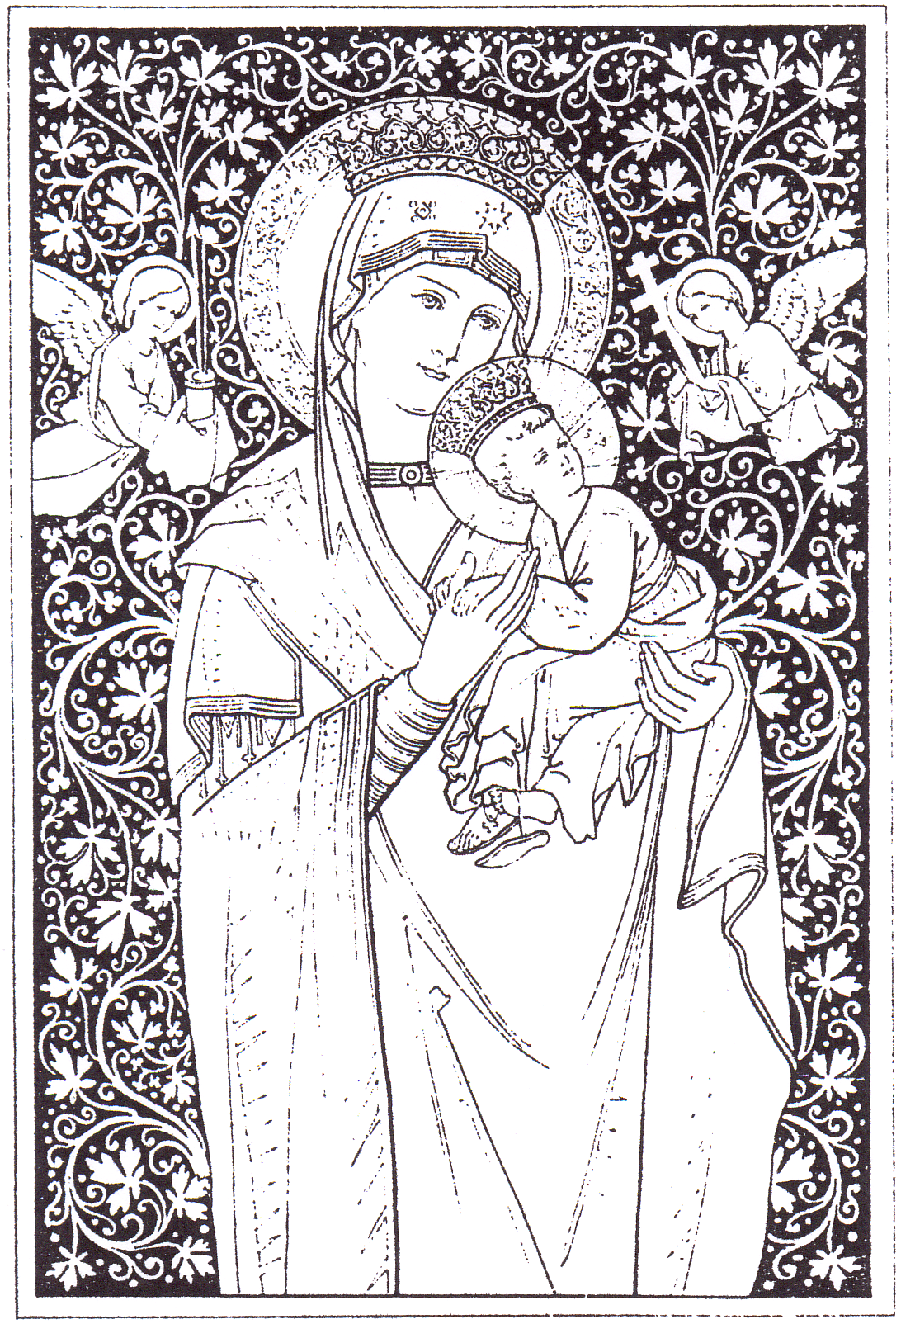

WHAT IS THE PART OF MARY, MOTHER OF CHRIST, IN ALL THIS?

“Be it done to me according to thy word.” --- the most momentous words spoken by any human being since the world began. The consent they gave allowed the immediate conception of God as a member of the human race.
It was a miraculous conception, a miraculous birth, leaving Mary “virgo intacta”.

Her consent made possible her Son’s redeeming act and His institution of the Church to continue His work. By His resurrection and ascension He personally led all of mankind through death to the life in union with God intended at creation but lost irretrievably by its now debased prototype.

To Mary we owe that given our co-operation “Each will then rise again, in the same body he had in this life" but glorified, transfigured. "The 'just' shall see God, one and three, as He is." [Council of Florence, 1438-1445, Denz.693]

THE DISCOURSE TO HIS APOSTLES AT HIS LAST SUPPER

CHRIST: I go to prepare a place for you, and if I go I will come again and take you to myself, so that where I am you also may be. You know where I go, and you know the way.

THOMAS: Lord, we do not know where you are going. How can we know the way?

CHRIST: I am the way, and the truth, and the life. No man comes to God the Father but by Me. [John 14:1-6]

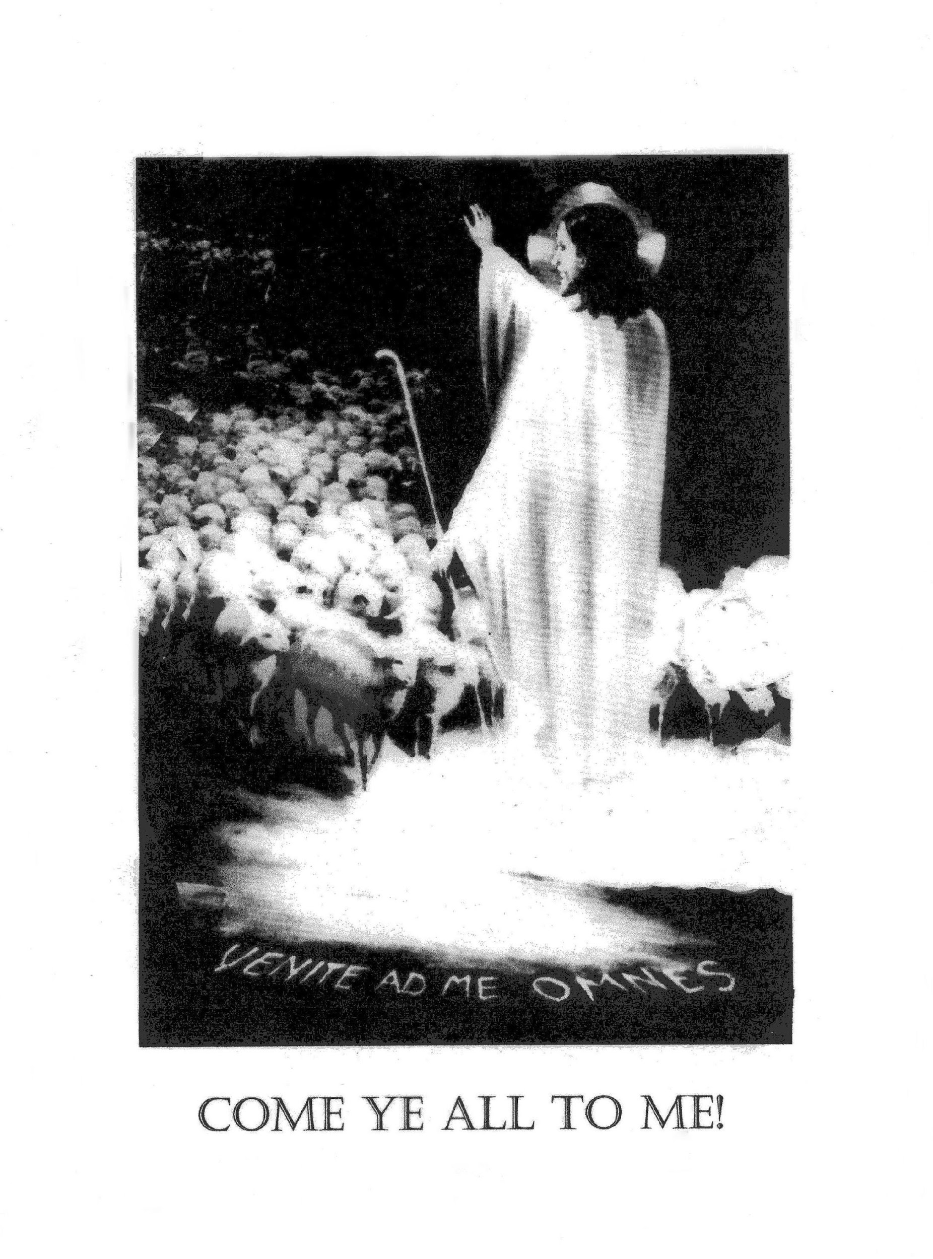

He was in the world, and the world was made by Him but the world knew him not.

He came unto his own,
but his own received him not.

But to as many as did receive him
he gave power to be made the sons of God

born not of blood, nor of the will of the flesh,
nor of the will of man, but born of God.

John 1:9-13

NOTES

THE STATE OF CHRISTIANITY IN EUROPE BY THE EARLY 16th CENTURY, which allowed the rise of the ‘Reformed’ or ‘Protestant’ Churches, also necessitated genuine reform of the Church, expressed and codified A.D.1563 in the clear, unequivocal statement of Christianity, The Catechism of the Council of Trent, from which Image and Likeness takes its facts:-

An Introduction to the Catechism of the Council of Trent, 1545-63, Article 1: Why and When the Synod of Trent decreed that this Catechism should be Publish'd.

"When all things were full of Hatred and Dissention, when the Unity of the Name of Christ was now almost pull'd and torn to pieces with Schisms and Heresies, Paul III of Sacred Memory, willing to put a stop to those so great Evils, in the Year of the Incarnation of our Lord 1537, appointed a General Council at Mantua; but as beyond expectation the City of Mantua could not be granted the Church 'twas necessary to make choice of another Place, the City of Trent in the Tyrol, and there he anew announces a Council, to be held on the Thirteenth day of December, Anno Dom. 1545. In the meantime it was wonderful to behold how greatly Luther’s Heresie crept abroad; and Impiety, the Child of War, had overspread almost all Europe, and there scarcely remain’d so much as the bare Shadow of Religion.
Now to take away and reform these Evils, the Fathers from all Parts hasten together to Trent; but, Good God! The Work appears Infinit, and in the Lake Lerna, there is not only one Hydra to be cut off, but the Work requires many Hands; which that the Fathers might furnish with Arms, they undertake to inform the Curats, who at that time were almost all void of both Learning and Religion; that thereupon the ignorant Vulgar might the more easily be taught.
There were made by the Heretics not only vast Volumes whereby they endeavor’d to overthrow the Catholic Faith; but also there were written almost infinit Books by them, which carrying in them the Titles and Shews of Piety and Religion, it is incredible how hard it was to discern the good Seed of Christ from the Tares of the enemy; and there were as many Catechisms carried about, as there are Provinces in Europe, yea, and almost as many as there are Cities; all which abounded with Heresies, and wherewith the Minds of the Simple everywhere were deceiv’d; and scarcely was there anyone well grounded in the Faith.
Wherefore the Fathers of the General Council of Trent, being earnestly desirous to apply some wholesome Remedy to this so great and dangerous Evil, thought it not enough to determine some of the Points of Catholic Doctrin against the Heresies of our Times; but held it further necessary, to appoint some certain way and Rule of Instructing Christian People in the Rudiments of Faith; which in all Churches they are to observe to whom is lawfully committed the Charge of Pastor and Teacher. Observe, O ye Pastors, and own this your Book, forasmuch as it was not only undertaken and publish’d for your sakes; but also the Use of it, by the very Council, is thus appointed you.
That the Faithful may come with the greater Reverence and Devotion of Mind to the Receiving of the Sacraments, This Holy Synod commands all Bishops, That not only when the Sacraments are to be ministered to the People by themselves they first explain the Use and Vertue of them, according to the capacity of the Receivers; but also, if there be need, and if it can conveniently be done, that they endeavour the same may be piously and prudently observ'd by the Curats, even in the Vulgar Tongue, according to a Form to be appointed by Holy Synod, in a Catechism concerning all the Sacraments, which the Bishops shall take care to have faithfully translated into the Vulgar Tongue, and by all Curats to be explain'd to the People. [Session 24, de Reform, c7.]"
"This Catechism was publish’d by command of Pope Pius V for the Benefit of the Christian Common-wealth, and for the restoring to us the ancient discipline of the Church. Pope Pius V took care that the Sacred Catechism for the Curats should be made first in Latin, and then render’d into the Italian, French, German and Polonian Language.”

It was not published in English until 1687, by order of King James II of England, 1685-1688. "The Catechism for the Curats, Compos'd by the Decree of the Council of Trent, and Publish'd by Command of Pope Pius the Fifth. Faithfully Translated into English. Permissu Superiorum, London, Printed by Henry Hills, Printer to the King's Most Excellent Majesty for His Houshold and Chappel, for him and Matthew Turner, M.DC.LXXXVII."
THE REFORMATION, A WIDELY HELD PERCEPTION:

“Religious movement of the 16th Century; its object reform of the doctrines and practices of the Church of Rome, ending in the establishment of the various Reformed or Protestant churches of central and north western Europe.

Its four main protagonists: Luther born 1483 … Germany
Zwingli “ 1484 … Switzerland
Knox “ 1505 … Scotland
Calvin “ 1509 … France

Principal points contended for: * the general use and authority of the Scriptures
* Justification by faith alone.

They repudiated: * the doctrine of Transubstantiation
* Supremacy of the Pope
* Worship of the Virgin Mary (in fact expressly prohibited by the Church)

Ulrich Zwingli by 1525 had rejected the Mass altogether; claimed the Eucharist to be purely symbolic
involving no 'real presence'." Harvey, The Oxford Companion to English Literature, London, 1933, pp.655, 866.

🙞

THE FACTS OF THE MATTER:
1. If Heaven is open to the individual by ‘faith alone’ (sola fides), there is no need for Sanctifying Grace, or the Mass and Sacraments that give and increase it. But these were instituted by Christ. Moreover, if the sacred nature of the Mass is set aside, then celibacy in its Ministers is no longer appropriate, an undeclared but possibly overriding, basic factor in the revolt.

2. Protestantism was nowhere eagerly sought by the populace through study; it was imposed on them by their rulers. Their own religious illiteracy on the one hand, and the scandalous laxity they observed in the clergy on the other, gained their acceptance of new religious practice.

3. Luther’s revolt was often politically and financially advantageous to their rulers, in independence gained and wealth appropriated from Church lands and property.

The revolt imposed on the English people was different. Henry VIII did not dispute Church doctrine, but authority, making himself, not the Pope, supreme authority on religion in his realm. He abandoned the Church by his Act of Supremacy, 1534. He did however appear to countenance ‘Justification by Faith’ when in 1545 he planned to dissolve the Chantries that abounded in mediaeval England, and divert their funds to himself. Chantries were a demonstration of belief in Purgatory, for they provided funds for Mass to be sung for donors’ souls, therefore incompatible with the reformers’ “Heaven by faith alone”. Henry VIII died (1547) before proceeding, but his successors lost no time in making dissolution of the Chantries law.
Authority in the Church of England rests in the Crown. Authority in the Christian Church rests with God, in His Vicar.

While the Reformation did not itself purify the Ministerial office, it did challenge the Church to do so. It occasioned a vast movement of reform within the Church, including stringent legislation concerning candidates for the priesthood. The deplorable state of the Church in the 16th Century was finally dealt with in true reform in the Council of Trent, 1545-1563.

AN HISTORICAL AND CHRONOLOGICAL INDEX
TO THE

NEW TESTAMENT Holy Bible, Westminster, 1914

A.D.
1 Christ is born at Bethlehem, Luke ii.
He is circumcised, Luke ii.
The wise men come and adore him, Matt.ii.
He is presented in the temple, Luke ii.
Joseph and the Blessed Virgin mother fly
with the child Jesus into Egypt, Matt. ii.
The massacre of the infants by Herod, Matt.ii.
Joseph with the Blessed Virgin and her Son, return from Egypt, but for fear of Archelaus, go and live at Nazareth in Galilee, Matt.ii.
12 Jesus is found in the Temple disputing with the doctors when he was twelve years of age, Luke ii.
30 St. John Baptist begins preaching penance, and to baptize. The chief of the Jews sends messengers to ask if he was not the Messias, John i.
Jesus himself is baptised by John. A voice from heaven declares him the beloved son of God; the Holy Ghost comes down like a dove, Matt. iii.; Mark i.; Luke iii.
Christ is no sooner baptized, but he retires into a wilderness, where he fasts for forty days. The devil there tempts him. The angels come and minister to him, Matt.iv.; Mark i; Luke iv.
Christ's first miracle at Cana in Galilee, by turning water into wine, John ii.
31 St. John Baptist is cast into prison, and beheaded by Herod, Matt.xiv.; Mark vi.; Luke ix.
Christ makes choice of twelve of his disciples, whom he calls Apostles. Peter is the first of them, Matt.x.; Mark iii.; Luke vi.
Christ's Sermon, or his instructions on the mountain, Matt. v, vi., and vii. He preaches in Judea and Galilee, casts out devils, cures all manner of diseases and sometimes on the Sabbath days, confutes and puts to confusion his adversaries, who blame him for it, Matt.xii.; Luke xiv., etc.
He raises to life the daughter of Jairus, Matt. ix.; Mark v.; Luke viii.
Also the son of the widow of Naim, Luke vii.
He calms the sea by his word, Matt.viii.; Mark iv.; Luke viii.
He heals the man thirty-eight years ill of a palsy, John v.
31 He sends his twelve Apostles to preach, with power of doing miracles, Matt.x.; Mark vi.; Luke ix.
He teaches them to pray, Matt.vi.; Luke xi.
He makes choice of seventy-two disciples, Luke x.

A.D.
32 He promises to make Peter the head of his Church, to build his Church upon him, to give him the keys of the kingdom of heaven, Matt. xvi.
He declares himself the Messias in plain terms to the Samaritan woman, John iv.
He excuseth his disciples for plucking the ears of corn on the Sabbath, Matt. xii.
He feeds at one time five thousand men with five loaves, Matt. xiv. At another time four thousand with seven loaves, Matt. xv.
He promises to give them his body to be truly meat, etc. Many even of his disciples leave him, looking upon that doctrine as hard and harsh, John vi.
33 His transfiguration, Matt.xvii.
The Sunday, or first day of the week in which he died on the cross, he came riding upon an ass into Jerusalem, Matt.xxi.
In the beginning of that week he went daily into the Temple, and in the evenings retired to Bethania, to pray in the garden of Gethsemani, Luke xxi, xxxviii., etc.
On Wednesday Judas made a bargain with the chief priests, to deliver him up to them for a sum of money, Matt.xxvi. 15.
On Thursday he sent his disciples in the afternoon to bring the paschal lamb, offered in the temple, which after sunset he ate with his twelve Apostles, Matt.xxvi.
He washed their feet, John xiii.
After supper he instituted the Blessed Sacrament and Sacrifice of his Body and Blood, Matt. xxvi.
He gave his Apostles those excellent instructions set down by St. John xiv-xvii.
Christ's prayer in the garden three times repeated.
He is there seized, being betrayed by Judas.
He is led away to Annas, and then to Caiphas.
33 He is condemned as guilty of blasphemy and death, for owning himself the Son of God. He is spit upon, buffeted, etc.
On Friday morning they deliver him up to the Roman governor, Pontius Pilate who sees and declares him innocent, yet fearing not to be thought a friend to Caesar, condemns him to the death of the Cross.
He dies on the Cross, and is buried. For the history of his Passion, see Matt. xxvi., xxvii., xxviii.; Mark xiv., xv., xvi.; Luke xxii. xxiii, xxiv.; John xxviii., xix., xx.

A.D. The miracles at his death, ibid.
33 He riseth from death the third day, ibid.
His different apparitions that very day; and others afterwards, ibid.
He gives his Apostles power to forgive sins. John xx.23.
He gives to St. Peter the charge over his whole Church, John xxi.
He promiseth to be with his Church to the end of the world, Matt.xxviii
After forty days he ascends in their sight into heaven, Acts i.
St.Matthias is chosen an Apostle in the place of Judas the traitor, Acts i.
The day of Pentecost, the Holy Ghost descended upon them, and upon all present with them, in a visible manner, Acts ii.
The wonderful change wrought in the Apostles by the coming of the Holy Ghost. Their undaunted courage, Acts ii., etc.
They preach the resurrection of Christ, the necessity of believing in him, of repenting and doing penance.
St. Peter, the chief of the Apostles, converts on one day three thousand, on another five thousand, Acts ii. 41, and iv.4.
He, with St. John, cures the lame beggar that sat at the gate of the temple, Acts iii.6.
The new Christians have all things in common. Everyone's necessities are supplied out of the common stock, Acts iv. 32.
Ananias and Saphira, for reserving some part of the money of a field sold, and for lying to the Holy Ghost, fall dead at St. Peter's feet, Acts v.
The election of the seven deacons, Acts vi. Saul, by virtue of a commission from the chief priests, persecutes the Christians, Acts ix.
St. Stephen is stoned to death, Acts vii, 58.
The ministers of the Gospel, being dispersed, preach in Judea and Samaria, etc.
St. Philip, in Samaria, baptizeth Simon the
Magician. He offers money to St. Peter to have the power of giving the Holy Ghost, Acts viii
A.D St. Paul is miraculously converted, going
34 to persecute the Christians at Damascus, Acts ix. He presently preacheth Jesus.
St. Peter cures Eneas at Lydda, and raiseth to life Tabitha at Joppa, Acts ix. The very shadow of his body cures all diseases, Acts v.15.

A.D. He received Cornelius the Centurion and
39 other Gentiles with him into the Church, Acts x.
He is thought to have gone about this time to Antioch in Syria, and to have founded the episcopal See.
41 He preaches in Pontus, Galatia, etc.
St. Barnabas and St. Paul preach at Antioch, where the believers were first called Christians, Acts, xi. 26.
42 Herod Agrippa puts to death St. James, the brother of St. John, and imprisons St. Peter,who was miraculously delivered, Acts xii.
St. Matthew, and afterwards St. Mark, wrote their Gospels.
43 St. Paul and Barnabas sent to preach in Pamphylia, Pisidia, Lycaonia. Afterwards in Pontus, Thracia, etc., Acts xiii., xiv.
48 St. Peter about this time wrote his first Epistle.
49 A dispute between St. Paul and some zealous converts that had been Jews, about the obligation of making even the Gentiles observe the Jewish laws, Acts xv.
St. Paul and Barnabas are sent to Jerusalem, to have this question decided by the Apostles, etc.
A council of the Apostles and Bishops decides the question, St. Peter speaking first, and St. James joining with him. The letter of the council to their brethren the converted Gentiles, Acts xv.
51 St. Paul and St. Barnabas separate, Acts xv.
52 St. Paul with Silas goes to Asia. St. Timothy and also St. Luke become his companions. He goes to Philippi in Macedonia, to Thessalonica, to Berea, to Athens. Finds there an altar dedicated to the unknown God, Acts xvi. 17.
He writes his first Epistle to the Thessalonians, and the second soon after.
He stays eighteen months at Corinth, Acts xviii.11.
55 He goes to Ephesus. After a short visit to the brethren at Jerusalem, he goes to Antioch; and from then again into Galatia and Phrygia, and stays three years at Ephesus, and thereabouts, Acts xix.
56 He writes to the Galatians.
57 He writes his first, and soon after his second Epistle to the Corinthians.
57 He prepares to go to Jerusalem with alms he had gathered, Acts xx and xxi.
He writes to the Romans.
58 He comes to Jerusalem, Acts xxi.

A.D. The Jews seize St. Paul in the temple;
58 being beaten and in danger of being murdered by them, he is rescued by Lysias the tribune and his soldiers, Acts xxi.
Lysias sends him to Felix the governor of Judea, then at Caesarea, where he was two years a prisoner.
His discourse before King Agrippa, Felix etc., Acts xxv.
60 Having appealed to the tribunal of Caesar, he is sent to Rome with other prisoners, Acts xxvii.
61 A description of his voyage and shipwreck on the coast of Malta. Everyone in the ship are saved, being two hundred and seventy-six persons, Acts xxvii. 44.
St. James about this time wrote his catholic Epistle.
St. Paul's arrival at Rome. He is kept under custody for two years, with a soldier to guard him, Acts xxviii.
62 He converts Onesimus,and sends him with his letter to Philemon. He writes to the Philippians and Colossians.
St. James, Bishop of Jerusalem, there martyred.
St. Paul, being set at liberty, writes to the Hebrews.
66 Goes again into Asia. Makes St. Timothy Bishop in Asia, and goes into Macedonia, from whence he writes his first Epistle to Timothy.
68 St. Peter about this time writes his second Epistle.
About this time St. Peter and St. Paul came to Rome. See Tillemont, etc.
Not long after they were both put in prison, and suffered martyrdom.
St. John about this time came to live in Asia and governed all those churches for many years.
St. John was put into a caldron of boiling oil at Rome, under Domitian, and banished to the island of Patmos, where he had those wonderful visions of his Apocalypse.
He returns to Ephesus, under the Emperor Nerva.
He writes his Gospel.
He dies at Ephesus under Trajan, about the year 100.

BIBLIOGRAPHY

Apologetics and Catholic Doctrine, Part I, Apologetics, 4th Edn., Most Rev. M. Sheehan, D.D., Dublin, Gill & Son Ltd., 1950.

Apologetics and Catholic Doctrine, Part II, Catholic Doctrine, 2nd Edn., Most Rev. M. Sheehan, D.D., Dublin, Gill & Son Ltd, 1947.

Apologetics and Catholic Doctrine, Part III, Catholic Morality, Rev. Bernard J. Kelly, C.S.Sp., D.D., Dublin, Gill & Son Ltd., 1951.

Aquin, St. Thomas, On The Truth of The Catholic Faith, Summa Contra Gentiles, Book One: God, trans. A.C. Pegis, Image Books, New York, 1955.

Catechism of the Council of Trent, English trans. by order of King James II, London, 1687.

Catholic Encyclopaedia, Robert Appleton Company, New York, 1912 - 1915.

Croft's Fullness of Sacrifice,

Elton, G.R., England Under the Tudors, A History of England, Vol. IV, London, 1965.

Daniel-Rops, What is the Bible?

Farrell W. and Healy, M.J., My Way of Life - Pocket Edition of St. Thomas, The Summa Simplified for Everyone, New York, 1952.

Gibbs, Fr., Marvels of Divine Grace.

Gould and Whitely, Vergil's Aeneid, Book 4, London, 1965.

Holy Bible, The, Westminster, London, Burns Oats and Washbourne, 1914.

Jackson, D.G.M., M.A., Schools Without God, Australian Catholic Truth Society No.1247, Melbourne, 1956.

Johnston, Rev. H.A., S.J., Our Sacramental Life Series, Parts I -IV, Melbourne, The Australian Catholic Truth Society, 1939., Talks on the Sacraments, Books 1-VII, Dublin, Longford, 1960.

Joyce, G.H., S.J., M.A., (Oxon), The Church, Catholic Encyclopaedia,The, Book III, pp.744-761, New York, 1913.

Kelly, Rev. J.F., Through Christ Our Lord, Melbourne, Australia, 1952.

Kinkead, Rev. T.L., The Baltimore Series of Catechisms, Books 1-1V, Rockford, Illinois, Tan, 1974.

Lasance Rev. F.X. & Walsh, Rev. F.A., O.S.B., The New Roman Missal, New York, 1945.

Le Buffe, Rev. F.P., S.J., Let's Look at Sanctifying Grace.

Many, Rev. Victor, S.S., Marvels of Grace, Trans. Rev. A.D. Talbot, S.S., Milwaukee, The Bruce Publishing Co., and London, 17 Red Lion Passage, Holborne. Preface by Gauthier, Montreal.

Martindale, Rev. C.C., S.J., Jesus Christ and His Gospel, Catholic Truth Society, London, 1958.

Omlor, Patrick Henry, Questioning the Validity of Masses using the New, All-English Canon, Reno, USA, Athanasius, 1969, The Robber Church, Collected Writings, Stoufville, Ontario, Canada, S.Mattacchione Co., 1998.

Poelz-Martindale, The Passion and the Glory of Christ, New York, Wagner; London, Herder, 1912.

Radecki, CMRI, Frs. Francisco and Dominic, Tumultuous Times: The Twenty General Councils of the Catholic Church and Vatican II and its Aftermath, Wayne, Michigan, St. Joseph's Media, 1995., What Has Happened to The Catholic Church? Aylmer, Ontario, Aylmer Express Ltd., 1994.

Rumble, Rev. Dr. L., MSC, Radio Replies, 2nd Edn., Sydney, Australia, The Catholic Press Newspaper Co. Ltd., 1952.

Sheed, F.J., A Map of Life, London.

The Light of the World, Book II, 3rd Impression, The Archbishops and Bishops of Scotland, Wm.Collins & Sons, Glasgow, 1961.

ACKNOWLEDGMENTS:
My grateful thanks to the following for timely technical help: Dr. E. Kearnan, Parish Priest 'Star of the Sea', Cottesloe;
R.J. and R.J.N. Harlow, Peppermint Grove; Stuart Waddell, Canada; Cecilia Omlor, USA; Scott Robinson, Jack in the Box; Michael Ryan, ‘Print It’; Phillip Richmond and Sam Kennedy, Computer West; Glen Saw; Denise & Robert Sanders, Down South Computers & Consultancy; Nancy Launer, Gill Hartley, Pamela Anne Shanks and all Busnet Computer Club Members; Nick & Sally Reynolds, Busselton, Western Australia; Robin Webb, Sales Executive, ‘Clockwork Print’, West Perth; Rita and Bill Westerhuis; Bill, Linda & Laura Meachem, Perth, Western Australia.
INDEX
Abel 75
Abraham 77, 81
Accidents 47
Adam x, 24, 75
Angels 24
Anointing, Last, 37, 52-53
Antichrist 83
Apostles 18-19, 64-65, 95, 100
Appearances 18-19
Aquinas xf.2, 4, 25f2, 30, 37, 39, 40, 83f1-5
Ascension 25, 40, 48, 77, 90
Atonement xi, 25, 74, 77, 90-93
Authority xi, 19, 62-65, 73, 82, xvii
Baptism xi, 2-3, 5-11, 20, 28-31, 34-39, 58-59, 83, 92
Bible 21-26
Bishoprics 94, 95, 96
Buddhism 6
Cain 75
Caiphas 81
Calvin xvii
Celibacy xvii f1
Church xi, 25, 56-65
Confirmation 37, 40-41
Contrition 12-16
Councils:
AD 1438-45 Florence: 99
AD 1545-63 Trent: xii, 6, 7, 8,
15, 30, 47, 56, 61, 77,
83f9, xiv, xvii
AD 1962-65 Vatican II: xii, f2
61, 77, 85, 88f
Creation viii, x, 5
Death 35, 64, 70-71, 83
Diagrams 12, 22, 36, 38, 87, 94
Didache 85
Eternity ix-xii,83, 97
Eucharist 37, 42-49, 87, 92
Evolution 23f, 24f.1
Existence ix, 23
Expiation 21-26, 72-73, 89, 93
Faith Alone (Sola Fides) 34, xvii
Freewill ix, x, xi, 13, 24, 34, 39, 45, 55
Gospels 6, 83, 96, xviii-xx
Grace:Supernatural x-xii, 2, 10-12, 14-16, 25, 30-35, 58-59, 97, xvii
Heaven 83, 97
Hell 83, 97
Heresy xi-xii, 56, 61f, 85f, xvi, xvii
Hierarchy, Jews 65, 66, 78-82
Illustrations v, vii, 3, 5, 11, 12, 13, 29, 38, 42-43, 45, 58, 60, 66, 69, 70, 72, 87, 89, 94, 98, xiii
Image viii-xii
Incarnation 25, 99
Intellect x, 38, 65
Isaac 77
Israel 64, 65, 75, 81 82

Jerusalem 25, 95
Jews 24-25, 65, 66, 72-82
Josephus Flavius 65
Judgment: Particular 83
General 83, 97
Justification 34, xvii
Justice 83
Justin AD.165, 85
Knox xvii
Lazarus 25, 78, 79
Likeness viii, x-xii, 30
Limbo 83
Lord's Prayer vi
Luther xvii
Machabees, 97
Mahommedans 6
Malachias 70, 77
Man, defined viii-xi, 24, 82-83, 97
Manna 44, 46
Marriage 37, 50-51
Mary iv, 24-25, 98-99, xvii
Melchisadech 77, 90, 96
Messiah 25, 45, 62, 63, 65, 66, 71, 80-82
Mosaic Law 50, 78f1, 79
Moses 75
Noah, 75
Order, Holy 37, 51, 94-97
Pagans 72, 9lfl
Pardon 12-16
Pasch/Passover 75-77, 79
Penance 12-16, 37
Pentecost 40, 64, 94
Perfection viii, x-xi, 28-38
Places: Alexandria, 95
Antioch 95
Bethany/Bethania 19, 78-79
Bethlehem xviii, 80
Calvary xii, 71, 81, 82 Capharnaum 44, 45
Cedron Brook 79
Constantinople 95
Corinth 34, 65, 84
Eden x, 38
Egypt 75, 86
Emmaus 18-19
Galilee 18-19, 63
Genesareth, Lake 63 Jerusalem 19, 25, 40-41, 46, 64, 65, 75, 78, 79, 82, 95
Jordan River 39
Lake Tibirias 18, 19
Mount of Olives 79, 91
Rome 65, 95
Philippi, 34
Samaria 40
Sinai, Mt. 81
Trent, Tyrol xvi

Prayer: The Lord's, vi,
of Praise 56
of Repentance 12
Pre-eminence, Peter's 19, 62-63, 65, xvii
Priesthood 1, 94-97
Prophecies 65, 77, 80-82
Purgatory 60, 83, 97, xvii
Redemption xii, 21-26, 71, 73, 97
Reformation xii, 56, xvii
Rejection x, 24, 65, 66, 77, 81, 82
Reparation 25, 92, 93
Repentance 12-16
Restitution xi
Resurrection 15, 17-19, 25, 40, 45, 63, 64, 73, 79-82, 90, 92, xix NT
Sacraments 36-55, 94-95
Sacrifice xi-xii, 68-74, 84-89, 93-95
Salvation 25, 71, 97, 100, xiv
Schism xi, xii, xvi-xvii
Secret, Discipline of, 91 f.1
Sin, The Original, x
Actual, 34
Society, Western xii
Soul ix, 37
Species, New 4-6
Supernatural Grace (see Grace: Supernatural)
Supremacy, Act of xvii
Teaching, Church's xi, 65, 97
Technicalities, Eucharist 90-93
Temple: of Solomon 91,
Destroyed, 65, 82, 85
The body, 2, 6, 16, 38
Testament, Old 93-95
New 84, 86,xviii-xx
Old and New x, xii, 64, 65, 75, 77, 82
Transfiguration 90fl, 99
Trent, See Councils
Triune God, xi, 38, 39, 55, 59, 61, 92,
93
Union 1-11, 20, 46-49, 93
Vatican II, See Councils
Vision, Beatific xi, 16, 30-33, 97
Will vi, x, 38-39, 65
Zwingli xvii

God alone is self-existent…existence is no part of human nature." M.Sheehan DD Apologetics Part II 2nd Edn.,Dublin, 1947, p..22
Pohle-Preuss, The Divine Trinity, Dogmatic Theology II, St. Louis, Mo., USA, 1912, p.10.
Aquin, St. T., On the Truth of the Catholic Faith: Summa contra Gentiles, Book One: God, trans A.C.Pegis, Image Books, New York, 1955, p.137.
See Notes, Part 3, p.xiv.
Initiatives of the Second Vatican Council 1962-65.
Rev.Dr.Rumble, M.S.C., Radio Replies, Second Edition, Sydney, Aust., 1952, Q.658, p.208.
My Way of Life, Pocket Edition of St. Thomas, The Summa Simplified, Walter Farrell, O.P., S.T.M. and Martin J. Healy, S.T.D., 5300 Ft Hamilton Pkway, Brooklyn 19, New York, 1952, p. 96-7.
Catechism of the Council of Trent, London, (1687 Edition), pp.171-2.
Kinkead, Rev.T.L., Baltimore Series of Catechisms, Book 3, New York, 1921, p.131.
Poelzl-Martindale, The Passion and the Glory of Christ, New York, 1919, pp.289-291.
Catechism of the Council of Trent, London, 1687, p.260, Note 54
ibid, p.238 Note 1
ibid p.238 Note 1
ibid, p.243, note 14
Poelzl-Martindale, “The Passion and the Glory of Christ”, New York, 1919, p.272 (Chronological Order]
2. ibid, pp.271-2.
Rev. Dr.Rumble, , MSC, Radio Replies, 2nd Series, Sydney, Aust. 1952, p.208, Q.658
Whether Man evolved over aeons of time or whether he flashed into existence by a single act of the will of his creator, is unknown and immaterial to the theme.
A.U.C., Ab urbe condito, Year from the building of Rome.
Mary was preserved from both original and actual sin. My Way of Life - The Summa Simplified for Everyone, Farrell & Healy, New York, 1952, p.476.
"The New Law of Grace", ibid., p.490.
Victor Many, S.S., Marvels of Grace, authorised trans. A.D. Talbot,S.S., The Bruce Publ. Co., Milwaukee, Geo. Coldwell Ltd., 17 Red Lion Passage, Holborn, London,W.C.1.
Trent Catechism, London, 1687 edition., p.172.
Rev.Gibbs, Marvels of Divine Grace, p.12.
My Way, pp.513-515.
My Way, the Summa Simplified, p. 489-490, 520.
Sheehan II, p.151, Wisdom, Understanding, Counsel, Fortitude, Knowledge, Piety, Fear of the Lord.
My Way, the Summa Simplified, p.528.
Kelly, Apol.III, p.54.
Catechism of the Council of Trent, 1687 edition, pp. 207-9.
The Complete Catholic Handbook for the Latter Days, London, Britons Catholic Library, Burns and Oates, 1921, p.47.
Lasance & Walsh, The New Roman Missal, New York, 1945, pp.1624-5.
The New Catholic Encyclopaedia, New York, 1967, p.349.
Sheehan, M., Apologetics and Christian Doctrine, Part 1 Apologetics, Dublin, 1950, pp 90, 136.
Ibid pp 92-5.
Kelly, J.F., Through Christ Our Lord, Melbourne, Vic., Advocate Press, 1952, p.87
Kelly, p.89
Maurice de la Taille, S.J. “The Mystery of Faith”, p.155, quoted in F. & D. Radecki, “What has Happened to the Catholic Church”, Aylmer, Ontario, 1994, p.164.
Commonly known as the Mass, it must be done only and strictly as defined and decreed by the Council of Trent, 1545-63.
By Jewish law, blasphemy carried the death sentence.
Poelzl, p.12.
According to Mosaic law, thirty shekels was the blood money for killing a slave, probably also the purchase price of a slave. Poelzl, p.22.
Sheehan, M. Apologetics and Christian Doctrine, Part 1, Apologetics, p.93-94
Crucifixion restricts breathing. The legs are instinctively braced in alleviation.
From them would come the Saviour, man’s re-instatement in grace.
Fahey, p.84,
ibid pp.132-133,
ibid pp. 110-112.
Fahey, Denis, The Kingship of Christ and The Conversion of the Jewish Nation, Dublin, 1953, pp.85, 120-124, 168.
My Way of Life: The Summa Simplified for Everyone, Farrell & Healy, New York, 1952, p.588;
ibid p.588;
ibid p..524;
ibid p.589;
ibid p.503;
Sheehan, M., Apologetics, Part II, p.300-301;
P.J. Toner, Catholic Encyclopaedia, Vol. lX, New York, 1910, pp. 256-9;
Sheehan, p.301;
Catechism of the Council of Trent, London, 1687, p.76 VIII.
“Do This”: Only the Apostles present received the order, and with it the power, to “Do This”. The need to impart their unique power to others, that all men might fulfil their duty of involvement, arises from the injunction of the Third Commandment to keep the Sabbath as a Holy Day.
This transformation (Matt.17:2) when “his face shone like the sun and his garments became white as snow” was the sole time Christ permitted his divinity to illuminate his humanity. Shown to Peter, James and John alone, it could be seen to prefigure the gloriously transformed life of the Christian in eternity.
Note: The Altar Servers, page 89, would at that point be seen holding the Priest’s Chasuble, to show their own union, and that of the whole congregation whom they represent, with the Action.
The “discipline of the secret”: It was the custom during the first centuries, particularly from the end of the 2nd to the beginning of the 6th, to conceal from the heathen the more sacred rites of Christianity, especially the real nature of the Eucharist. [Sheehan II, p.160.] “Give not that which is holy to dogs. Neither cast ye your pearls before swine: lest perhaps they trample them under their feet: and turning upon you, they tear you.” [Christ’s Sermon on the Mount, Matt. VII:6.]
Sheehan II p.242-3
Sheehan, M., Apologetics, Part II, Dublin, 1947, p.188.
Kelly, Rev. J.F. Through Christ Our Lord, Melbourne, Vic., 1952, p.111.
Sheehan, M., ibid, pp.275-301.
Sheehan II, p.245: “Celibacy of the clergy is not of divine, but of ecclesiastical, institution. It was generally observed during the first three centuries, and was imposed as a law in the Western Church about the year 400 A.D.”
Dr.Rumble, M.S.C., Radio Replies, Second Series, Sydney, Aust., 1952, p.63, #164;
ibid p.62, #161; p.63, #164, 165; p.67, #178
ibid p.63, #163.
Elton, G.R., England under the Tudors, London, 1965, p.205;
Rumble, p.74, #201.

